Are You Really My Friend?

What is a friend?
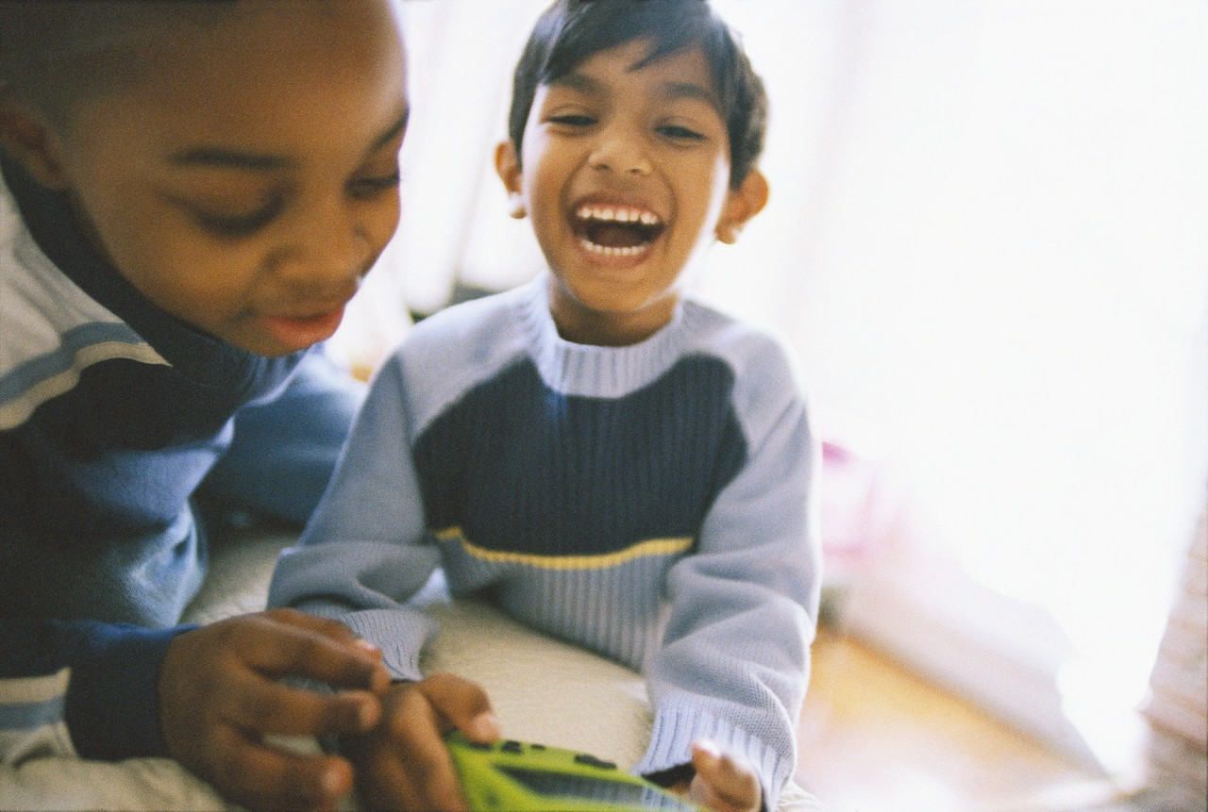
A friend is someone that you like to be with. A friend plays with you and laughs with you.
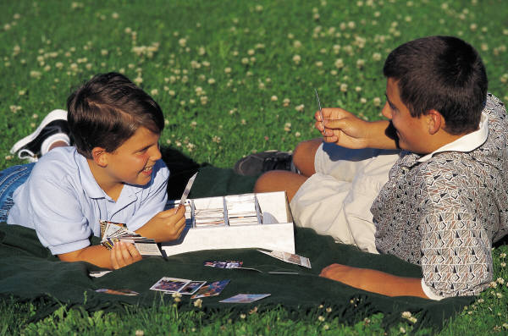
A friend is someone who will talk with you and share with you.

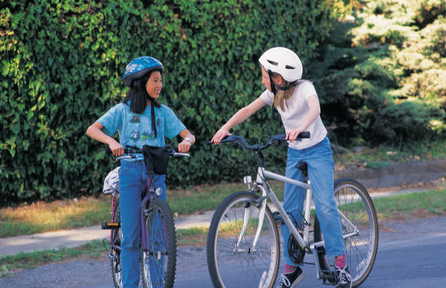
Do you think these kids are friends?
They are talking on the school bus. They are being friendly.

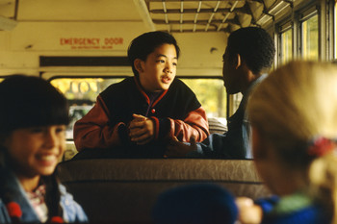
These kids are friends!

Do you think these kids are friends? They are having a snack together. They are looking at each other and laughing.

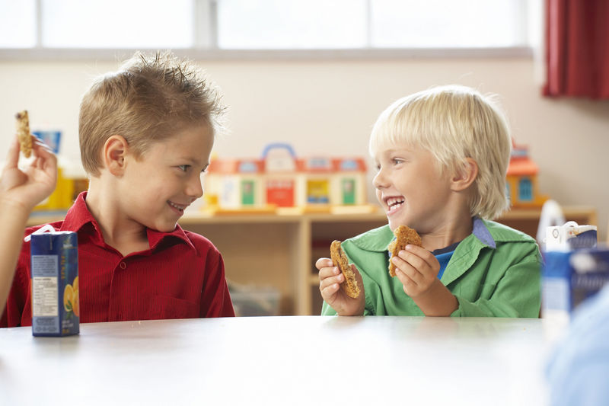

These two boys are friends!

Now look at this picture. Are the girls being friendly to the boy?

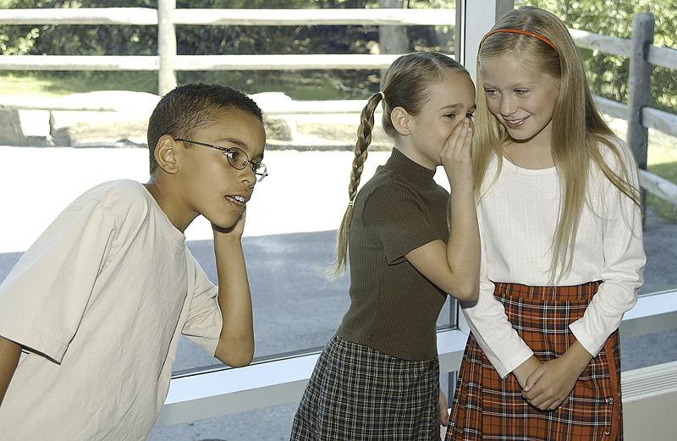

The girls are laughing, but they are not including the boy. They are telling secrets and laughing at the boy. They are not being friendly to the boy.

They are teasing him.

How do you know when someone is teasing? When someone is teasing, they tell secrets about you and laugh with their friends.

When someone is teasing, they try to get you to say or do something that you don’t want to do. If you do it, they might laugh at you. They are not being friends!



If a kid tries to get you to say or do something that you don’t want to do, tell them –

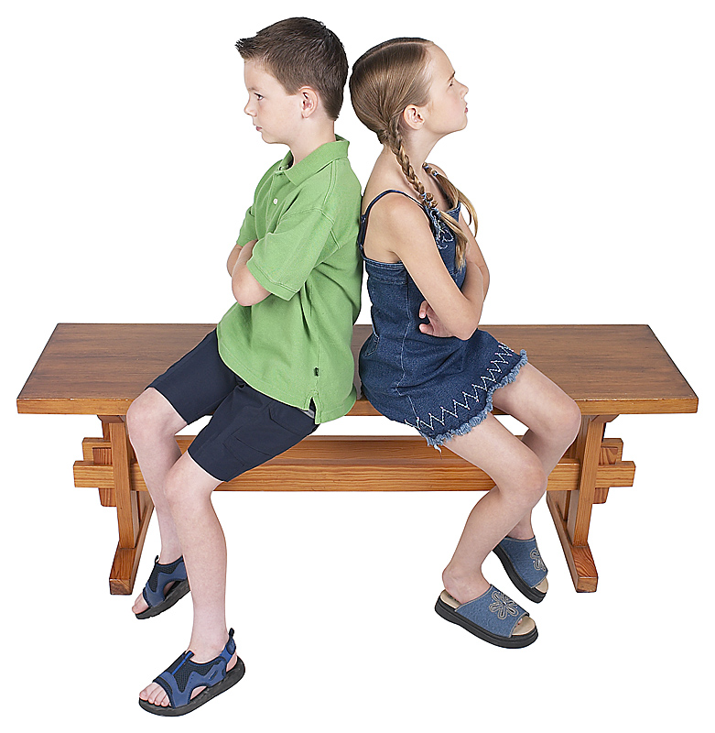
Cut it out!
Stop bothering me!
or

It is best to talk to people that are being friendly.

