
People Wear Different Kinds of
Underwear
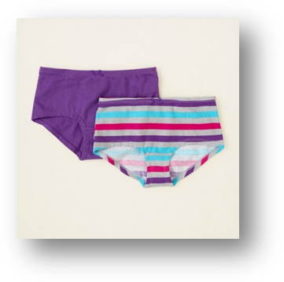
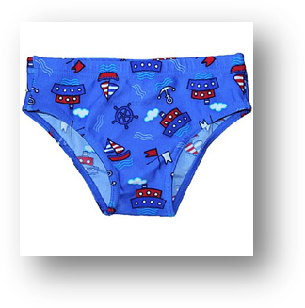
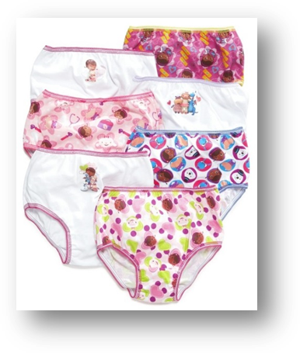

Babies don’t wear underwear. They wear diapers.
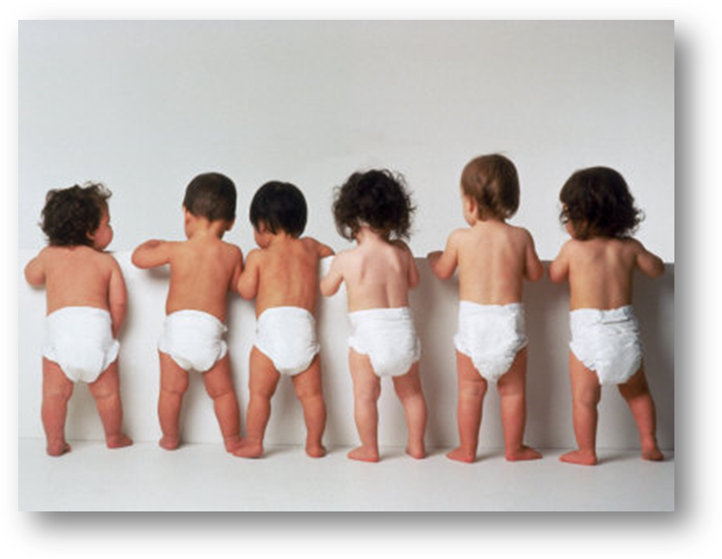

When babies grow up to be big boys and girls,
they learn to pee and poop in the toilet.

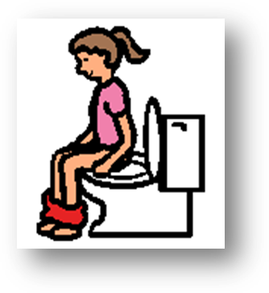
When people learn to use the toilet they wear underwear.
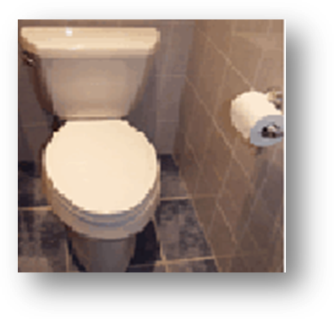

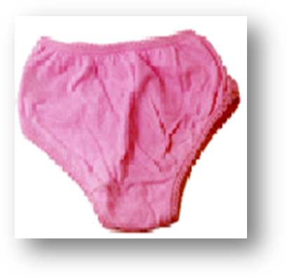
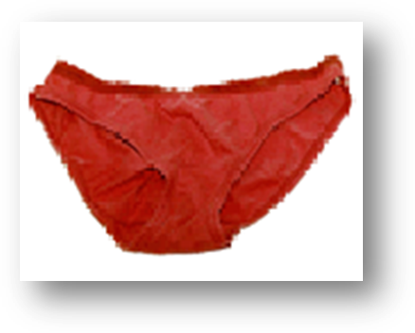

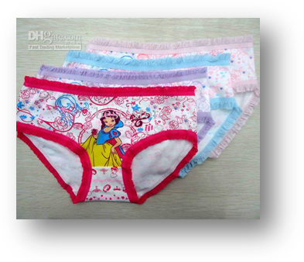

My Mommy wears underwear and my teacher wears underwear.
Even[PLACE NAME OF STUDENT FAVORITE CHARACTER HERE] wears underwear.

There are different kinds of big girl underwear.
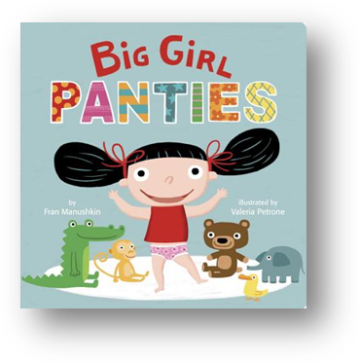
Some are just one color like these.
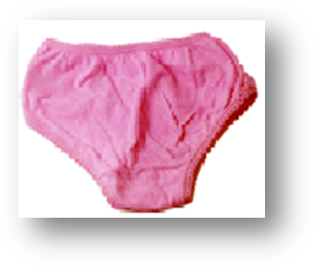
Some underwear has polka dots,
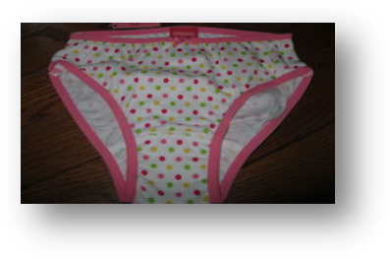
And some have pictures of Hello Kitty on them.
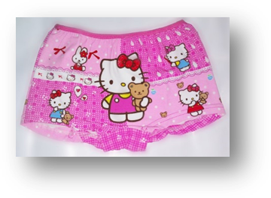

[Place picture of ‘special interest’ character with underwear item placed on the character] ________wears different underwear every day.

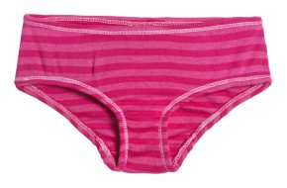

Some days ___ wears underwear with stripes.

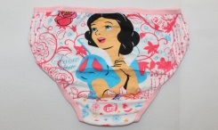
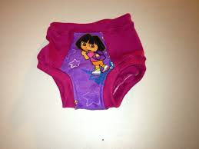
Some days she likes to wear underwear with Disney Princesses or Dora pictures.

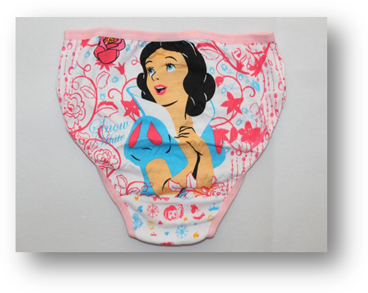
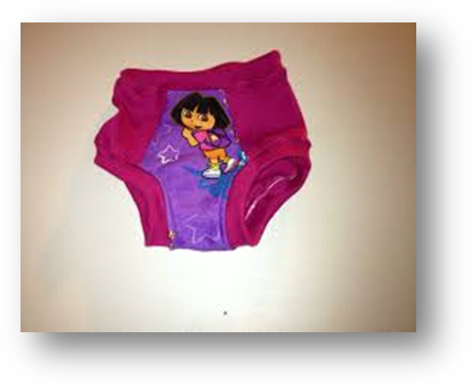

It is fun to wear different kinds of underwear.

I can try to wear different kinds of underwear just like [insert picture of favorite character]

I can try to always to pee in the toilet like [insert name of favorite character]

That will make Mommy, Daddy and [teacher] happy.

That will make [insert name and picture of favorite character] happy.

That will make me happy too!!!
