
All By Myself

It’s fun to go to school.
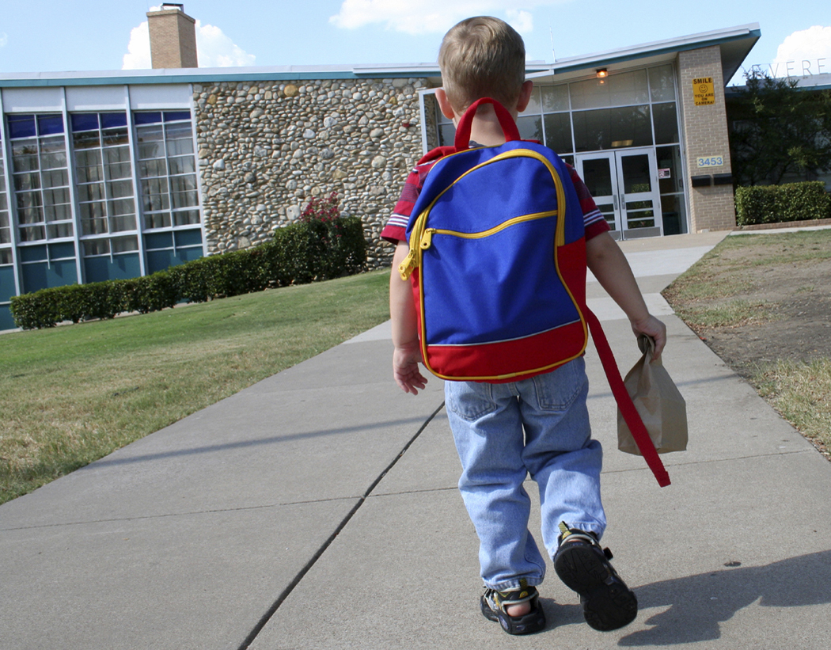
There are lots of friends at school.
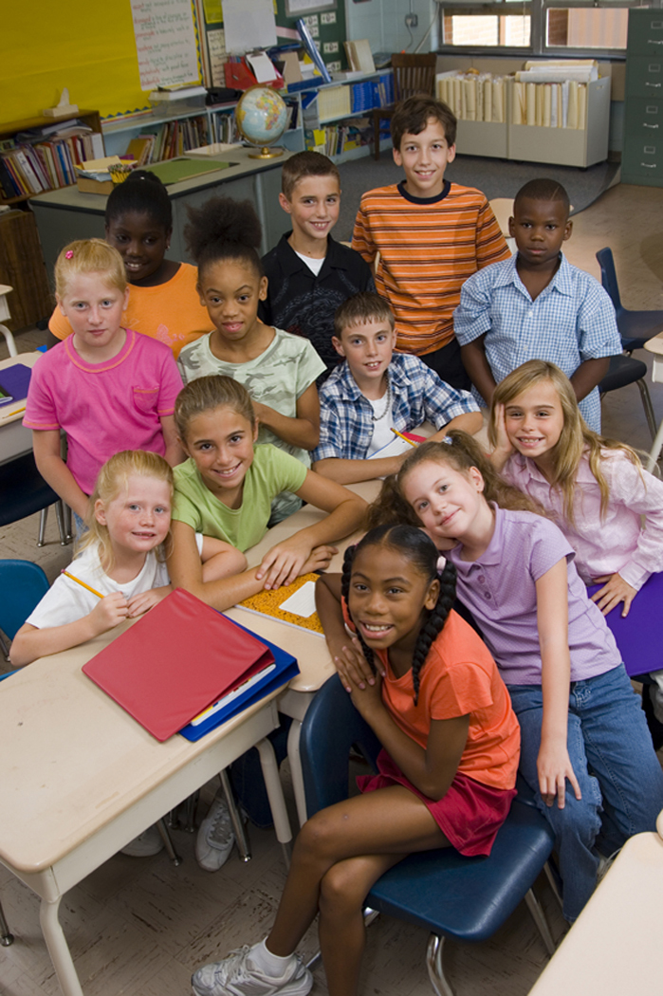
I can do so many things in my class each day.
Sometimes there is someone that helps me. That’s OK.
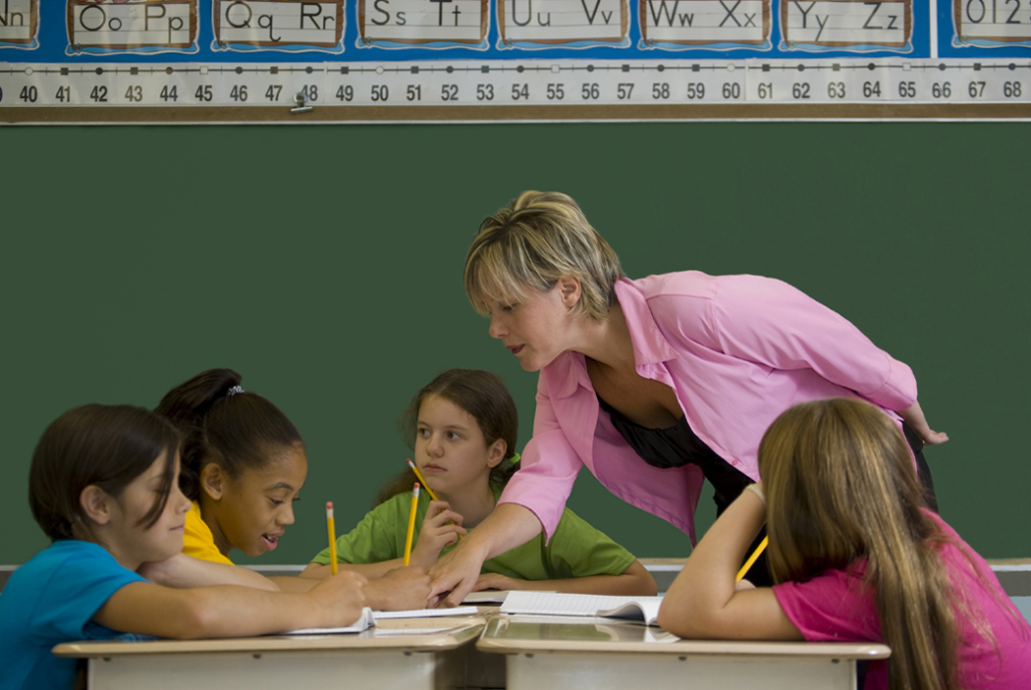
But, sometimes I need to do my work
all by myself.
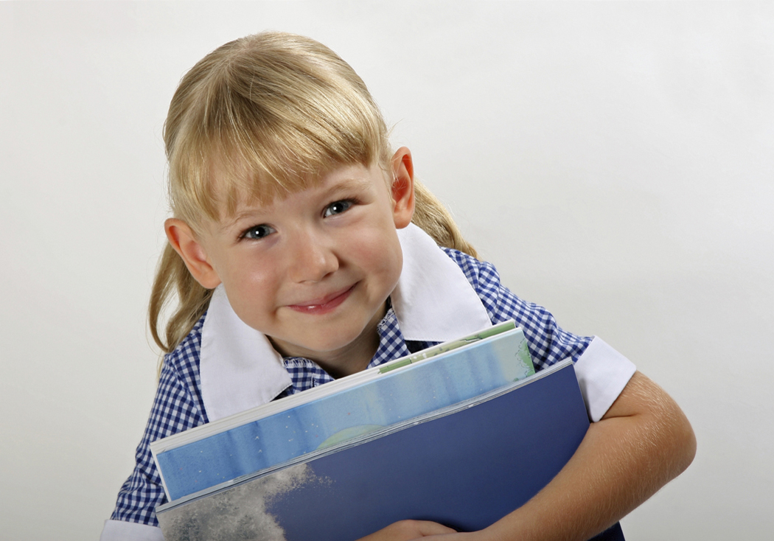
I can do it
all by myself.
When my teacher gives a direction, I will try to follow it
all by myself.

When it is time for snack, I can get my snack,
all by myself.

When it is calendar time, I will walk to circle and sit down,
all by myself.

When it is time to put my things away, I’ll clean up
all by myself.

When it is time to work at my table, I can do it,
all by myself.

I will try to do it,
all by myself.

I can do it. I can do it,
all by myself.

