This week I might try:

To use good manners

I’ll try to remember that there are good manners everyone should use.

I can keep track of what I’m learning on the chart below:
If I’m assigned to work in a group this week, I’ll try to: | Day  1 | Day  2 | Day  3 | Day  4 | Day  5
- Say “please” and “thank you”

- Say “you’re welcome”

- Wait my turn

- Say “excuse me”

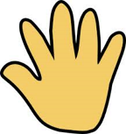
- Say “hi” and bye”

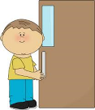
- Hold the door

- Use a quiet voice

- Share

- Use good table manners

- Say “I’m sorry”

