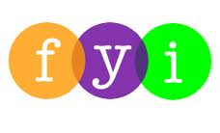
Social Skills –Parent Note

Your child just completed a social skills lesson. The topic was:
I Can Feel Good About Myself. Your knowledge of this lesson may help you to help your child generalize the skills to other environments.

What he/she learned:

- The definition of “Self-Esteem” – how we think and feel about ourselves; how we value ourselves
- Healthy self-esteem is not bragging, thinking you’re perfect, or thinking you’re better than everyone else
- Why having a healthy self-esteem is so important
- Things that can affect our self-esteem
- Ways we can boost our self-esteem
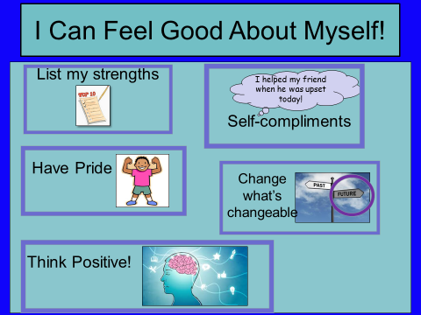
Your child received a Lesson Summary magnet:

If you have a moment, email _____________________________ with any information that might help your child for the next lesson on ________________________. THANK YOU!!
adapted from www. kidshealth.org

