ACTIVITY 1: I Can Feel Good About Myself
MAKE A “STRENGTHS” COLLAGE

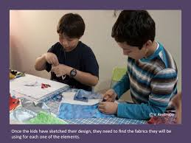
Give students magazines (sports, food, fashion, technology/science, etc.) and have them cut out pictures that represent their strengths. (You might want to have one you’ve done about yourself to share.) Provide large paper, glue sticks, glitter, markers, etc. and let them create a collage that shows the things they’re good at. When everyone is finished, ask each student to talk about their collage to the group. Let the students ask questions and/or make comments about similarities or differences. (If a student struggles with something but sees that a classmate has listed it as a strength, he might ask for help from this classmate.) Once everyone has shared their collages, you can hang them around the room to serve as self-esteem boosters! Refer students to their collages whenever they start feeling down on themselves.

ACTIVITY 2: I Can Feel Good About Myself

YOU HAVE SUPERPOWERS!

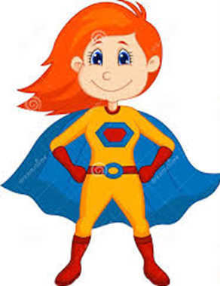
Tell the students to imagine they had a superpower – ask what it would be. Then provide paper, pencils, crayons, markers, etc. and let them draw themselves with their superpower. Encourage students to share their drawings and talk about how having that superpower would make them feel. Remind students that even though we can’t really have a superpower, we can still feel good about the skills we do have.

