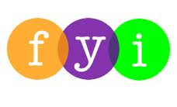
Social Skills –Parent Note

Your child just completed a social skills lesson. The topic was:
Don’t Be a Rude Dude: Using Good Manners and Being Polite. Your knowledge of this lesson may help you to help your child generalize the skills to other environments.

What he/she learned:
- What are good manners? What does being polite and showing respect mean?

- What does rude mean?

- 10 Good Manners we ALL should use
- Say “please” and “thank you”
- Say “you’re welcome”
- Wait your turn
- Say “excuse me” but don’t interrupt
- Say “hi” and “bye”
- Hold the door
- Use a quiet voice
- Share
- Use good table manners
- Say “I’m sorry”

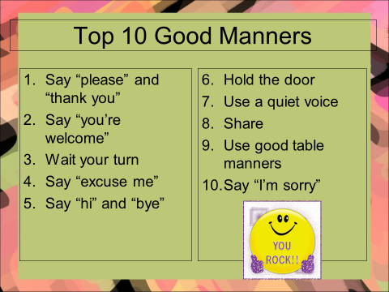
- So what do YOU think?

Your child received a Lesson Summary magnet:

If you have a moment, email _____________________________ with any information that might help your child for the next lesson on ________________________. THANK YOU!!

