Social Skills –Teacher Note

Your student just completed a social skills lesson. The topic was:
I Can Read Body Language. Your knowledge of this lesson may help you to help your student generalize the skills to other environments.

What he/she learned:

- Body Language is a way to communicate without using words

- There are four things we need to look at in order to read Body Language:

- Facial Expressions – eyes and mouth
- Posture – head, back and shoulders
- Gestures - hands
- Stance – arms and legs

- We also need to be aware of the messages our bodies are sending through our own facial expressions, posture, gestures, and stance

- Eye contact is important to show attention and interest in the other person. If direct eye contact isn’t comfortable, try looking at the other person’s forehead instead

Your student received a Lesson Summary magnet:
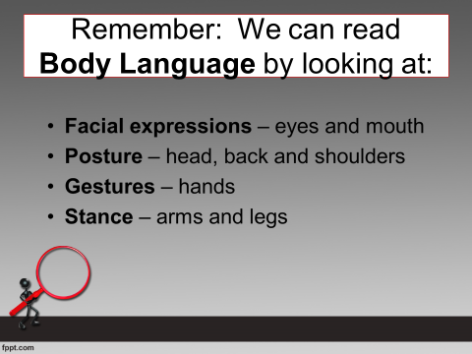

If you have a moment, email _____________________________ with any information that might help your student for the next lesson on ________________________. THANK YOU!!

