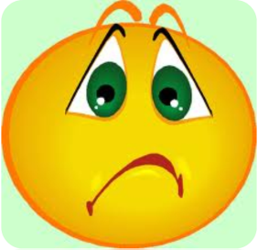
LESSON: Emotional Regulation Skills –
What Should I Do About Worries?

OUTLINE:

- What kind of things do you worry about?

- What do you do when you are worried?

- Things to try when you are worried:

- Talk to an adult
- Make a worry box - Activity
- Do something that makes you feel good
- Try a little exercise
- Figure out how to solve the problem

- Sometimes we can’t change things so we have to “let it go”

- Review above strategies to help students move past worries

- So What Do You Think?

- Lesson Summary Card

MATERIALS NEEDED:

- Facilitator’s Guide
- Shoe boxes, construction paper, stickers, glue, scissors markers (Worry Box)
- Lesson Summary Cards
- Homework Sheet - optional

