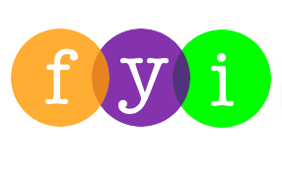
Social Skills – Parent Note:

Your child just completed a social skills lesson. The topic was:
Mealtime Manners – You Gotta Eat, Right? But You Gotta Eat RIGHT! Your knowledge of this lesson may help you to help your child generalize the skills to other environments.

What he/she learned:

- Good manners are about being thoughtful, polite, and respectful
- There are manners we ALL should use at mealtimes
- These manners include
- Sitting at the table
- Chewing with mouth closed
- Not stuffing your mouth
- Using your napkin
- Saying “excuse me”
- Saying “please” and “thank you”
- Eating your own food
- Saying “no thank you” instead of being rude
- Cleaning up after yourself

Your child received a Lesson Summary magnet:
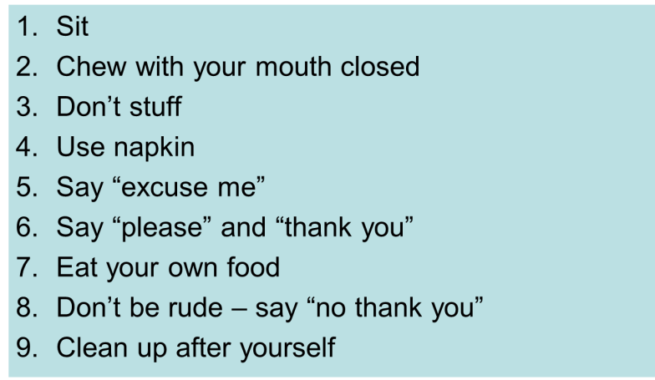
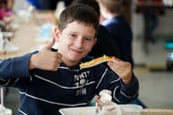
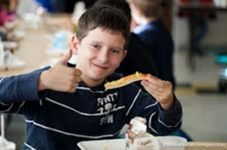

If you have a moment…

Email ___________________________ with any information that may help your child for the next lesson on ___________________________. THANK YOU!

