What’s Happening Today?

Let’s Talk About Table Manners

- What are good manners? (being thoughtful, polite, respectful)

- What manners should we use at mealtimes?

- Sit
- Chew with your mouth closed
- Don’t stuff your mouth
- Use your napkin
- Say “excuse me”
- Say “please” and “thank you”
- Eat your own food
- Say “no thank you”
- Clean up after yourself

- So what do YOU think?
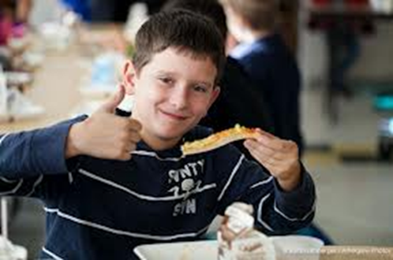
- Get your magnet!

