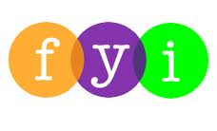
Social Skills –Parent Note

Your child just completed a social skills lesson. The topic was:
I Can Take Care of My Body. Your knowledge of this lesson may help you to help your child generalize the skills to other environments.

What he/she learned:

- We take care of our bodies by eating healthy foods, exercising, getting enough sleep, and keeping clean.
- Keeping our bodies clean helps us wash away dirt and germs so that we can stay healthy.
- 3 Things to Remember to Keep Our Bodies Clean
- WASH – (face, body, hands and feet, hair)
- BRUSH – (hair, teeth, nails)
- WEAR – (clean clothes, clean socks and underwear, deodorant)
- We need certain things to keep clean:
- soap, water, shampoo, washrag, towel
- brush/comb, toothbrush and toothpaste, nail brush
- washer/dryer and laundry detergent, deodorant/antiperspirant
- When we keep our bodies clean and healthy, other people might like to be around us more.

Your child received a Lesson Summary magnet:
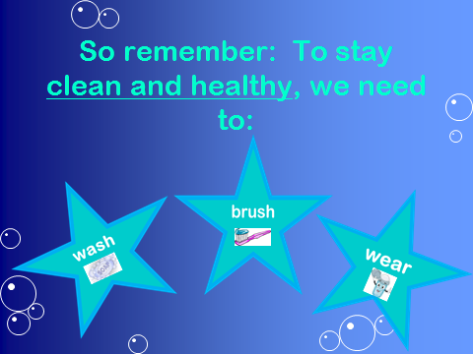

If you have a moment, email _____________________________ with any information that might help your child for the next lesson on ________________________. THANK YOU!!

