What’s Happening Today?

Let’s Talk About Taking Care of Our Bodies

- How do I take care of my body?

- Keeping clean = staying healthy!

- 3 Things to Remember to Keep Our Bodies Clean

- Wash
- Brush
- Wear

- What things do we wash with?
- What things do we brush with?
- What things do we need to keep our clothes and bodies smelling clean and fresh?

- So…what do YOU think?
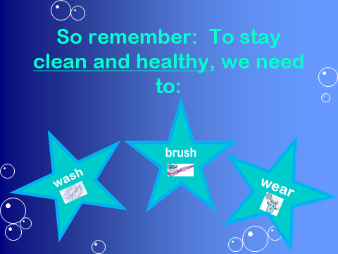
- Get your magnet!

