Social Skills –Teacher Note

Your student just completed a social skills lesson. The topic was:
What to Do About Gossip and Rumors. Your knowledge of this lesson may help you to help your student generalize the skills to other environments.

What he/she learned:

- Rumors and gossip are everywhere at school. The way we handle rumors and gossip can keep them from spreading

- Rumors and gossip can hurt others, destroy trust, violate privacy, and believing rumors/gossip can lead to bad choices

- There are things we can do to break the rumor/gossip chain:

- Make the rumor/gossip stop with you by not passing it on
- Not listen to the rumor in the first place
- Be a peacemaker
- Remember that private things should remain private

Your student received a Lesson Summary magnet:
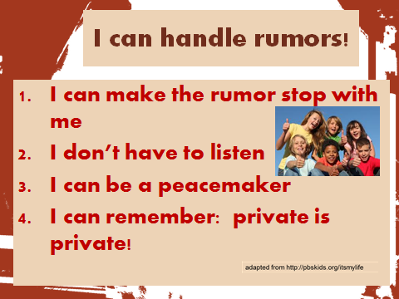

If you have a moment, email _____________________________ with any information that might help your student for the next lesson on ________________________. THANK YOU!!

