Social Skills –Teacher Note

Your student just completed a social skills lesson. The topic was:
What to Do About Bullying. Your knowledge of this lesson may help you to help your student generalize the skills to other environments.

What he/she learned:

- Bullying can take different forms (verbal, physical, social, psychological)

- A bully can be: one person or a group; someone the same age or older; a “friend”; a sibling; an authority figure

- People bully others for different reasons (they’ve been bullied themselves; they think it will make them popular/cool; they want attention; they want others to be afraid of them; jealousy)

- Bullying can make you feel: like it’s your fault; like you need to be the class clown; like you’re alone; unsafe/afraid

- Strategies to handle bullying:
- Stay calm
- Stay away
- Hang out with friends
- Have some comebacks ready
- Don’t bring expensive stuff/lots of money to school
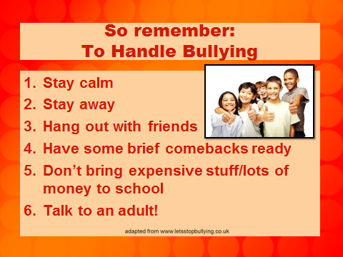
- Talk to an adult!

Your student received a Lesson Summary magnet:

If you have a moment, email _____________________________ with any information that might help your student for the next lesson on ________________________. THANK YOU!!

