Social Skills – Teacher Note:

Your student just completed a social skills lesson. The topic was:
Emotional Regulation Skills – What Should I Do About Worries? Your knowledge of this lesson may help you to help your student generalize the skills to other environments.

What he/she learned:

- Different kinds of worries (grades, friends, school, etc.)

- Strategies to try:

- Talk to an adult
- Make a worry box
- Do something that makes him/her feel good
- Try exercise
- Figure out how to solve the problem
- Let it go

Your student received a Lesson Summary magnet:

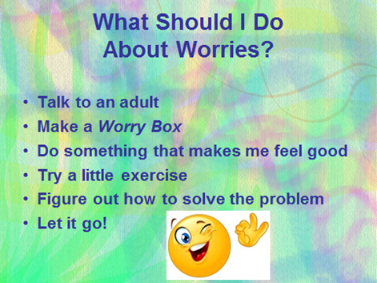

If you have a moment…

Email ____________________ with any information that might help your student for the next lesson on ________________________________.
THANK YOU!

