This week I might try:

To handle gossip and rumors

I’ll try to remember that there are ways to respond to gossip and rumors that can keep them from spreading.

I can keep track of what I’m learning on the chart below:

If I hear gossip or rumors this week, I’ll try to: | Day  1 | Day  2 | Day  3 | Day  4 | Day  5
1. Make the rumor or gossip stop with me

2. Not listen to the rumor or gossip

3. Be a peacemaker

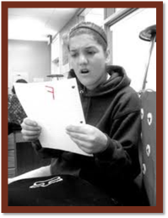
4. Remember that private is private!

