This week I might try:

To deal safely with bullying

I’ll try to remember that there are ways to respond to a bully that might not make the situation worse.

I can keep track of what I’m learning on the chart below:

If I’m confronted by a bully this week, I’ll try to: | Day  1 | Day  2 | Day  3 | Day  4 | Day  5
- Stay calm

- Stay away

- Hang out with friends

- Have some comebacks ready
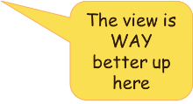

- Not bring expensive things/lots of money to school

- Tell an adult!

Some good ways to stay calm are:
Take a deep breath
Squeeze my hands together
Count slowly to 10

