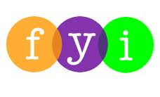
Social Skills –Teacher Note

Your student just completed a social skills lesson. The topic was:
I Can Stay Safe Online. Your knowledge of this lesson may help you to help your student generalize the skills to other environments.

What he/she learned:

- Ways we use the computer (homework, games, surfing the Internet, social media)

- Online safety – the SMART strategy

- S – Keep SAFE (never tell name, address, phone number)
- M – Don’t MEET (never meet an online “friend” without adult permission)
- A – Never ACCEPT (never accept emails/texts from unknown persons)
- R – Ask ‘is it RELIABLE’ (not everything we see on the Internet is true)
- T – Always TELL (tell an adult if something/someone upsets you)

Your student received a Lesson Summary magnet:

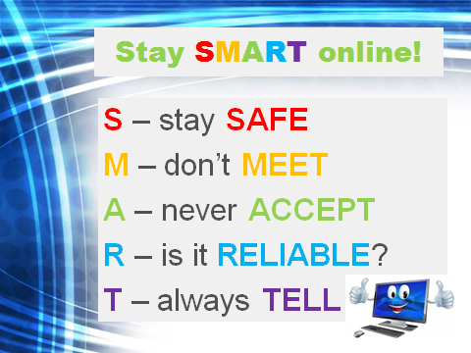

If you have a moment, email _____________________________ with any information that might help your student for the next lesson on ________________________. THANK YOU!!

