Internet Safety Pledge
Place a in each circle after you’ve read it carefully. Sign the bottom to agree to the pledge. Hang the pledge near your computer to remind you and your family to be safe online.

- I promise to never send or post personal information, such as my full name, address, phone number, or school name

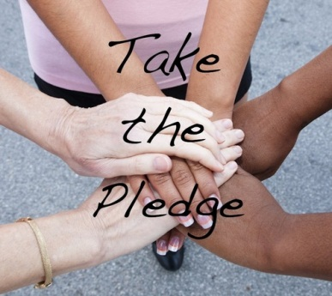
- I will never send a picture of myself to anyone without a parent’s permission

- I will not open emails from people I don’t know

- I will not follow links to sites that I do not recognize

- I will tell an adult if I see any information on the Internet that makes me feel uncomfortable

- I will never give out my passwords to anyone, except my parents

- I will never download and install files to my computer without a parent’s permission

- I will never email or post mean or hurtful things about other people

- I will follow all Internet rules set by my parents

Using the Internet is a special privilege for responsible people. I promise to be safe online.

X _________________________________________________ _________________________
Name Date
www.superteacherworksheets.com

