Social Skills – Teacher Note

Your student just completed a social skills lesson. The topic was:
What to Do About Cyberbullying. Your knowledge of this lesson may help you to help your student generalize the skills to other environments.

What he/she learned:

- The definition of cyberbullying – using tech devices to post things that hurt someone’s feelings or threaten someone.

- Cyberbullying can happen through text messages, emails, chat rooms, social media.

- People cyberbully others by posting embarrassing pictures, spreading lies/rumors, pretending to be your child online fooling your student into giving out personal information, sending threatening emails or texts.

- Cyberbullying can happen anywhere, anytime, and by anyone. Cyberbullies continue because they can remain anonymous. They may even say worse things through tech media than they would in person.

- Your student may think cyberbullying is their fault. It’s important that they don’t blame themselves.

- Your student learned 6 ways to handle cyberbullying:
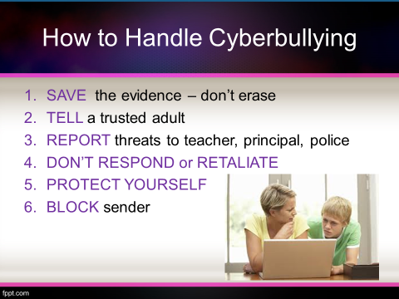
- Save the evidence – don’t erase
- Tell a trusted adult
- Report threats to teacher, principal, police
- Don’t respond or retaliate
- Protect yourself by not giving out personal
information
- Block the sender

Your student received a Lesson Summary magnet:

If you have a moment, email _____________________________ with any information that might help your student for the next lesson on ________________________. THANK YOU!!

