This week I might try:

To deal safely with cyberbullying

I’ll try to remember that there are ways to handle cyberbullying that might make things better.

I can keep track of what I’m learning on the chart below:

If I’m confronted with cyberbullying this week, I’ll try to: | Day  1 | Day  2 | Day  3 | Day  4 | Day  5
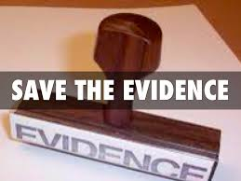
- Save the evidence

- Tell an adult

- Report threats to school staff or police

- Don’t respond or retaliate

- Protect myself by not giving out information

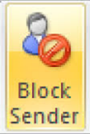
- Block the sender

