Social Skills –Parent Note

Your child just completed a social skills lesson. The topic was:
I Can Work in a Group. Your knowledge of this lesson may help you to help your child generalize the skills to other environments.

What he/she learned:

- At school, sometimes you work by yourself, and sometimes the teacher wants you to work in a group.
- Group work can be fun!
- Why it’s important to learn to work as a member of a group. (i.e. to hear other’s ideas, to learn to compromise; to contribute to the group’s goals, etc.)
- GROUP RULES: (easy to remember using the letters in the word GROUPS)

- Get along
- Respect other’s ideas
- On task
- Use quiet voices
- Participate
- Stay in your group

Your child received a Lesson Summary magnet:
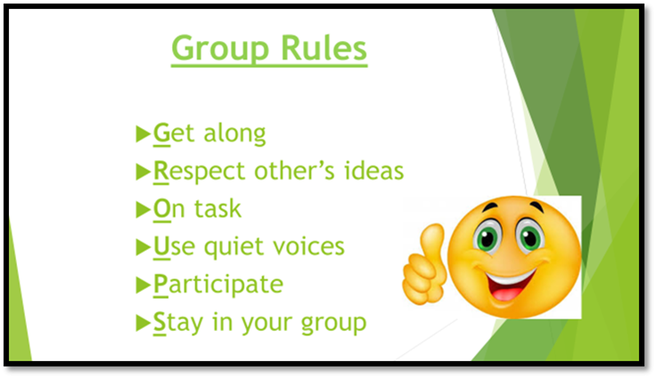

If you have a moment, email _____________________________ with any information that might help your child for the next lesson on ________________________. THANK YOU!!
adapted from www. teachjunkie.com

