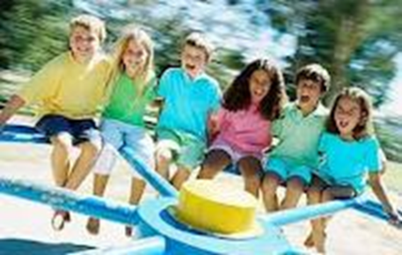

LESSON: FRIENDSHIP SKILLS – Having Fun at Recess

OUTLINE:

- What do kids do at recess? What do you do – have fun/not have fun?

- What kind of problems can happen at recess?

- What do to if:

- you don’t know what to play
- you want to join in
- you don’t know how to play

- Things you can say

- So What Do You Think?

- Lesson Summary Card

MATERIALS NEEDED:
- Facilitator’s Guide
- Props for Activity – optional (ball, hopscotch board, jump rope, etc.)
- Lesson Summary Cards
- Homework Sheet - optional

