This week I might try:

To calm down when things go wrong

I’ll try to remember that school is usually fun, but sometimes things go wrong and I get upset. To calm down, I can take deep breaths, close my eyes, count to 10, squeeze a ball, and ask to take a break.

I can try to keep track of the ways I calmed down when I was upset on the chart below:

This week: | Day  1 | Day  2 | Day  3 | Day  4 | Day  5
Took 5 slow deep breaths
Closed my eyes
Counted slowly to 10
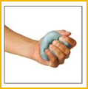Squeezed a ball
Asked to get a drink
Got back to having fun!

