Social Skills – Teacher Note:

Your student just completed a social skill lesson. The topic was: Friends and Teasing. Your knowledge of this lesson may help you to help your student generalize the skills to other environments.

What he/she learned:

- Friends are fun to be with.
- Friends like to spend time together and play.
- Friends are kind and do not tease.
- If someone is teasing, I should:
  - Join some friends who are being kind
  - Stand near or talk to an adult
  - Ask them to stop.

Your student received a “Social Power” Point magnet:

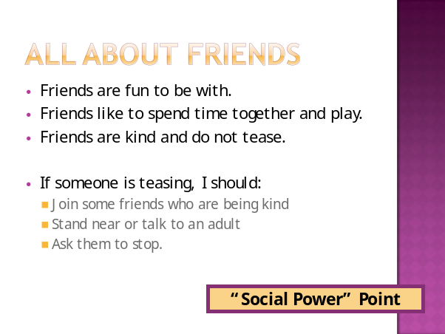

If you have a moment…

Email ___________________________ with any information that may help your

student for the next lesson on ____________________________.

