Social Skills – Teacher Note:

Your student just completed a social skill lesson. The topic was: Talking About How I Feel. Your knowledge of this lesson may help you to help your student generalize the skills to other environments.

What he/she learned:

- Sometimes you can tell how other people feel by looking at them, but sometimes people tell us how they feel.
- It’s not always easy to talk about how you feel.
- If you’re not sure how you feel, you can try to figure it out by thinking, writing, or drawing about it.
- It helps to remember what happened and how it made you feel so that you can talk to someone about it.
- Talking about how you feel is important because someone else might be able to help you.
- Talking about how you feel can help you feel better.

Your student received a Lesson Summary magnet:
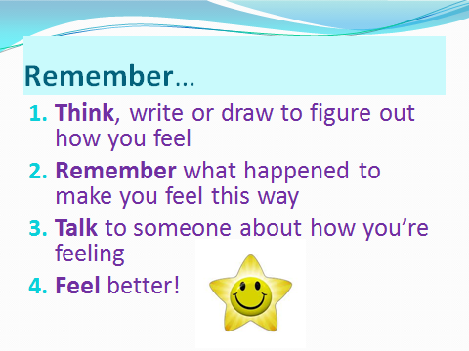
If you have a moment…
Email ___________________________ with any information that may help your student for the next lesson on ____________________________. THANK YOU!

