Social Skills – Parent Note – Let’s Play Together Part 2: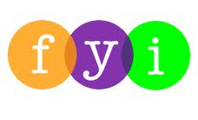

Your son/daughter just completed a social skill lesson. The topic was: Let’s Play Together. Your knowledge of this lesson may help you to help your child generalize the skills to other environments. You may be able to:

What he/she learned:

- Sharing means letting my friend use something that I am playing with.
- Taking turns means that both friends get to play with the toy.
- I’ll try to remember the rules about Sharing and Taking Turns:
  - When I want something my friend has, I can look at my friend and say his name.
  - I can put out my hand and ask for it.
  - He might say OK and give me the toy – then I can let him have a turn later.
  - Or, he might say “Not right now”. Then I’ll find something else to play with for awhile.

Your child received a “Social Power” Point magnet:

If you have a moment…

Email ___________________________ with any information that may help your child for the next lesson on ____________________________.

