Social Skills – Parent Note: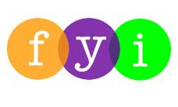

Your son/daughter just completed a social skill lesson. The topic was: Hellos and Goodbyes. Your knowledge of this lesson may help you to help your child generalize the skills to other environments. You may be able to:

What he/she learned:

- Greet someone the first time you see them each day,
- There are different types of greetings for different people.
- Goodbyes are for when you are leaving.
- There are different types of “Goodbyes” for different people.
- A wave can say “Hello” or “Goodbye”

Your child received a “Social Power” Point magnet:

If you have a moment…

Email ___________________________ with any information that may help your child for the next lesson on ____________________________.

