What’s Happening Today?

Let’s Talk About Hellos and Goodbyes…

- Saying “Hello”

- Let’s practice saying “Hello”

- Different “Hellos” for different people

- Saying “Goodbye”

- Let’s practice saying “Goodbye”

- Different “Goodbyes” for different people

- Get your “Social Power” Point magnet!

- So what do you think?

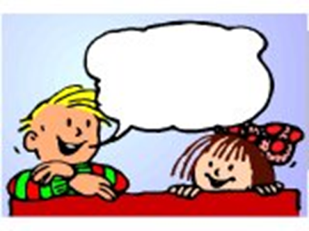
Hi Lily!

