Activity Sheet 2 – Let’s Play Together

Practice playing with toys with a friend. Each time you use one of these “rules” place a star in the square. Bring your paper back to school next week to show your teacher.
I looked at my friend   | I tapped my friend on the shoulder 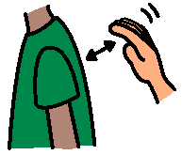 | I said my friend’s name  Joey…
I kept trying  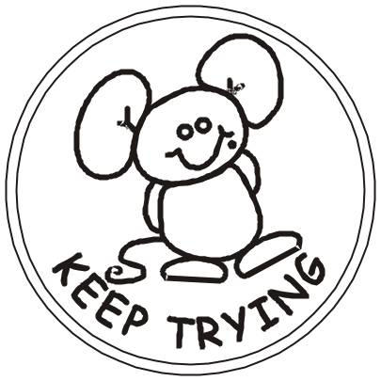 | I asked my friend for a toy  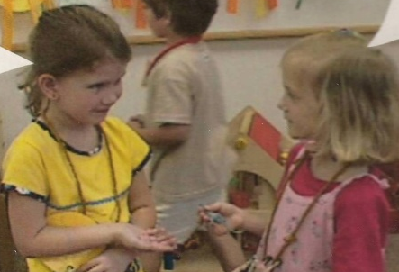 | I held out my hand when I asked for a toy 
I shared with my friend  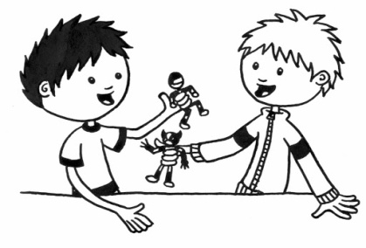 | I said, “Not right now” politely   | I had fun playing with my friends.

