This week I might try:

To use Greetings and Goodbyes

I’ll say “Hi” or “Hello” when I meet someone for the first time each day. I’ll try to remember to say it just one time. I’ll say “Goodbye” when I’m ready to leave. I’ll also try to wave to my friends.

I can try to keep track of how I used greetings and goodbyes on the chart below:

This week: | Day 1 | Day 2 | Day 3 | Day 4 | Day 5
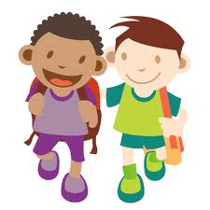

I said “Hi” to a friend.
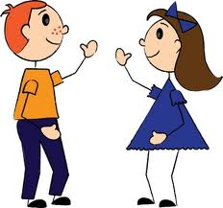

I said “Hello” to my teacher.

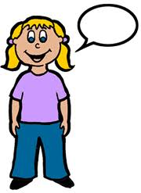
I said “Goodbye” when I was ready to leave.
I gave my mom, dad or Grandma a hug when I said goodbye.

Circle the word “Hi” or “Bye”. Cross out any other word:

Hi Bye dog the Bye Hi

