Lesson: Emotions and Triggers
Activity Sheet 1
  Feeling ________________________  Possible Trigger ________________  Possible Thought ______________  Possible Action ________________ | 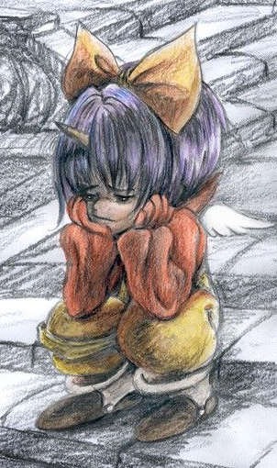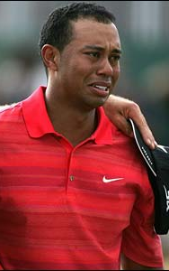  Feeling ________________________  Possible Trigger ________________  Possible Thought ______________  Possible Action ________________
  Feeling ________________________  Possible Trigger ________________  Possible Thought ______________  Possible Action ________________ |   Feeling ________________________  Possible Trigger ________________  Possible Thought ______________  Possible Action ________________
  Feeling ________________________  Possible Trigger ________________  Possible Thought ______________  Possible Action ________________ | TRIGGERS -  I have to wait in a long line – I feel frustrated.  A family member dies – I feel ___________.  I win a contest – I feel ___________.  A friend wins a contest – I feel ___________.

