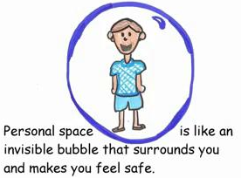

When you get too close to people, and touch or grab them when they do not want to be touched, they will not like it, feel very uncomfortable, and even feel afraid and not safe.
If people say your behavior makes them uncomfortable or scares them, EVEN IF YOU DID NOT MEAN IT THAT WAY, you can get into big trouble!

A person could ask a teacher, principal, boss, or a police officer to help them tell you to stop.
You could get sent home from school, fired from your job, or even arrested.

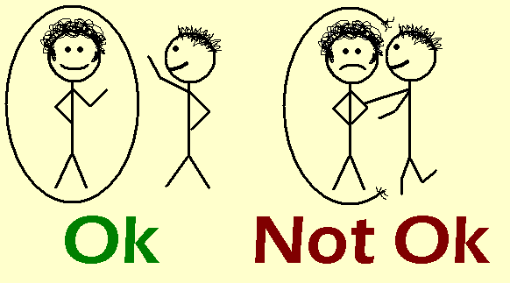
It is against the law to get too close to someone, including someone you like, and touch, grab or push them when they don’t want to be touched. It is still against the law, even if you say you are sorry.

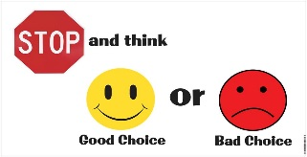 REMEMBER TO STOP AND THINK, instead of getting too close and touching someone.

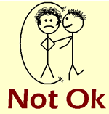 Instead of touching anyone --
1. You can – Talk, Say hello, Start a conversation, Wave, Smile, Keep your hands at your side, Squeeze your hands together
Control your body.
Control your behavior.
Follow the laws and everyone will feel comfortable and safe.

