When My Friend Gets Too Loud!

My name is [insert student’s name]. I am ____ years old. I go to [insert school name and photo]

I have fun at school. I have friends. Some friends are boys, some friends are girls.
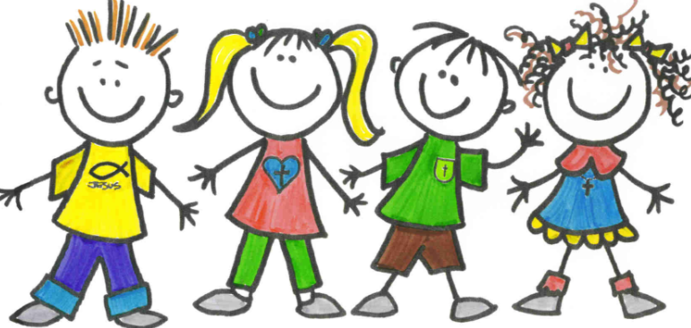

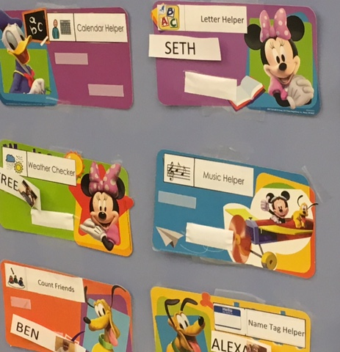
I pick a job at school. We have rules that help me.

Sometimes one of my friends is so noisy. I might hear a friend cry.
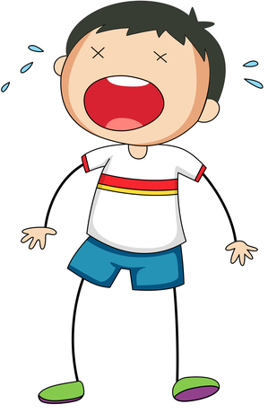

If a friend cries I can:
Take a deep breath. Then blow it out. Let’s practice.
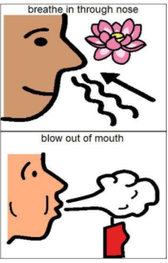

Very good!!!

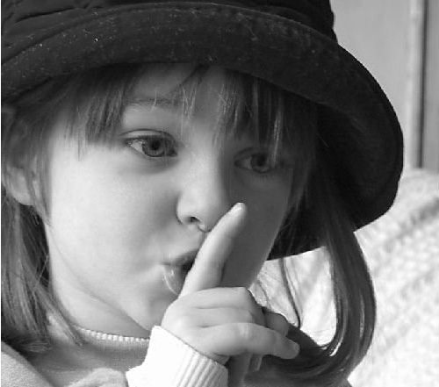
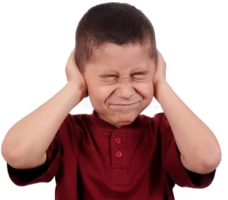
I can cover my ears and say SHHHHHH!

Good job!

I can say “feel better.” I can walk away.
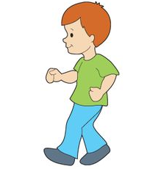
Ahh I feel better!

Now I can play with my friends. [Insert photo of child playing with description]

If I hear crying I can breathe in and out, I can cover my ears and say ‘shh’, I can walk away, then I can give a ‘Thumbs Up’ to tell my teacher I did it!
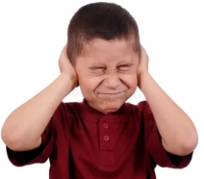
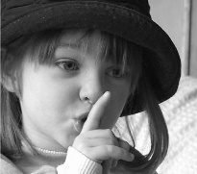
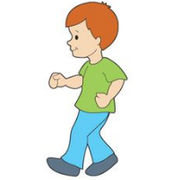
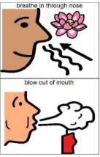

I can say “It’s OK”. “Feel better!”

Now we can have fun!

