WHEN I’M DONE WITH MY DRINK
Sometimes I pour my drink when I am finished. Sometimes I pour it on the table. This is a baby pouring her drink.
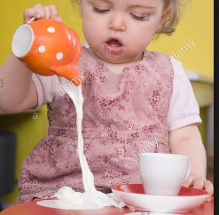
NO POURING ON THE TABLE BABY

I am a big boy. This is me!
Place picture of student here.

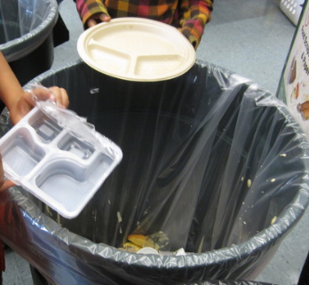
When I finish my drink I pour it in the trash can.

I am finished with my drink! I walk to the trash can.
Place picture of student walking to the trash can

Here I am pouring my drink in the trash can!
Place picture of student tossing drink container into the trash can.

I can do it!

