

When I Feel Angry

I Can Make Choices

I Can Handle My Anger in Good Ways!

When I feel angry, I can:
1. Get away from the person who is making me mad. If I am at home, I can go to another room.
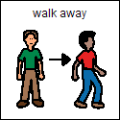

At school, I can ask to go to a quiet spot in my classroom.
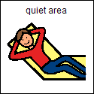

2. Tell Mom, Dad, teachers, sisters, and kids that I feel angry. My voice can be upset, but I need to use nice words.
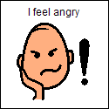

3. Ask to take a five minute break from an upsetting job or job that I do not like to do.
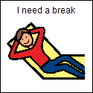

4. Squeeze and pound play dough or any squishy, soft thing.



5. Count to five and take five deep breaths and then blow them out.
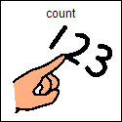

When I feel angry, there are things that I can do and things that I can not do!

I can not hit, kick, or hurt myself or others in any way!

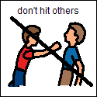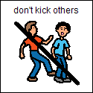

If I remember to do some of the 5 things when I feel angry, I can start to feel better and not so angry.

