**What To Do When I Get Hurt**

Sometimes I may get hurt.

**I bumped my head and it hurts.**

C:\Users\bonniej\AppData\Local\Microsoft\Windows\Temporary Internet Files\Content.IE5\6DIF0052\j0434407[1].wmf

**I cut my finger. Ouch!**

**OUCH hurts.**

C:\Users\bonniej\AppData\Local\Microsoft\Windows\Temporary Internet Files\Content.IE5\6DIF0052\j0423812[1].wmf

[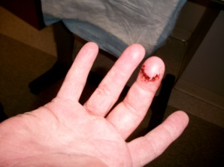](http://www.google.com/url?sa=i&rct=j&q=smiley+face+hurt+finger&source=images&cd=&cad=rja&docid=FjUx6ZXTg9sw1M&tbnid=Ur02DqGFJ_TjwM:&ved=0CAUQjRw&url=http://ddalliance.wordpress.com/2010/03/08/the-finger-incident/&ei=RtybUbCSOee60QG1xoH4Bw&psig=AFQjCNH7VEyDHd4CfS5Wz7B0qKT5JR5lwQ&ust=1369255171416629)

**I poked my eye and it hurts.**

[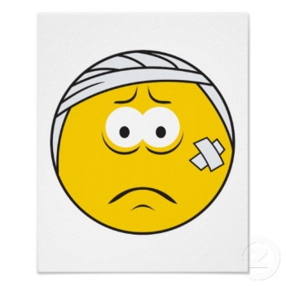](http://www.google.com/url?sa=i&rct=j&q=smiley+face+boo+boo&source=images&cd=&cad=rja&docid=YRK5GpfRvZ3zRM&tbnid=TwY2bV__GLI_JM:&ved=0CAUQjRw&url=http://www.zazzle.ca/injured_boo_boo_smiley_face_print-228798026440530390&ei=kdqbUezSBLG90QHTqICoCQ&bvm=bv.46751780,d.dmQ&psig=AFQjCNEJkhg0rwwBGXywBCOtVwT3AzQIKQ&ust=1369254916612403)

**I have a boo-boo on my face.**

All boys and girls get hurt sometimes. They may cut a finger or bump their head or scrap an elbow or knee.

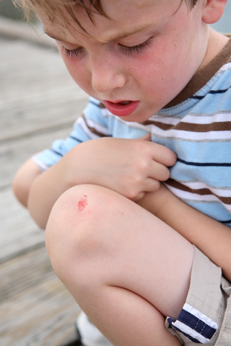. [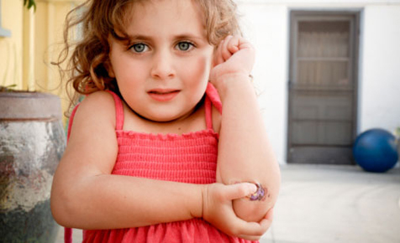](http://www.google.com/url?sa=i&rct=j&q=smiley+face+scrape+knee&source=images&cd=&cad=rja&docid=kmIHGEgnK033EM&tbnid=uLBQBCZO2RMW6M:&ved=0CAUQjRw&url=http://readanddigest.com/health-benefits-of-sunlight-natural-source-of-vitamin-d/&ei=PN2bUfqeLsf30gHfqYDwBA&psig=AFQjCNEgxjicAA1_ElQAAkJSI-EjtY4hdg&ust=1369255597590171)

What should a boy or girl do when they get hurt?

[](http://www.myspace.com/koolkart/photos/34864065)

**I hurt myself. Ouch! What should I do?**

Sometimes boys and girls are sad and maybe even cry when they get hurt.

[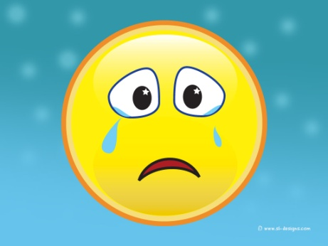](http://duabroad.com/2012/05/)

It is okay to be sad or cry when you get hurt.

[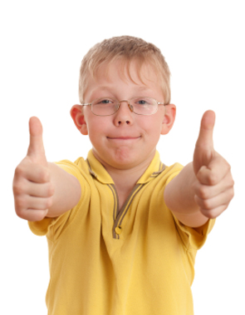](http://www.google.com/url?sa=i&rct=j&q=children+okay&source=images&cd=&cad=rja&docid=HNQSPkKItLX51M&tbnid=pAnEatLzkighuM:&ved=0CAUQjRw&url=http://www.lactoflora.es/ninos/eficiacia.html&ei=U-KbUYuFCNKy0AG6koCABQ&psig=AFQjCNHftoOyj2b3P2XVHy9eyyroHvmPEQ&ust=1369256903290572)

[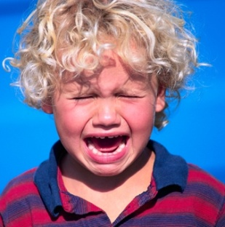](http://www.google.com/url?sa=i&rct=j&q=child+crying+face&source=images&cd=&cad=rja&docid=WMe7Uj-IybgUpM&tbnid=FdCgkRi6jkcivM:&ved=0CAUQjRw&url=http://www.nomurapreschool.com/2012/i-dont-like-mondays-tips-for-dealing-with-your-childs-separation-anxiety/&ei=q-ObUeCfJeHa0QHl8ICoDA&psig=AFQjCNHe9-sBw0HdSY65OY6Qmyx4QxHqRw&ust=1369257185565836)

When boys and girls get hurt, they should tell an adult.

[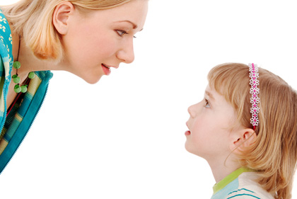](http://www.google.com/url?sa=i&rct=j&q=child+tell&source=images&cd=&cad=rja&docid=AAl4f2PmeKhiOM&tbnid=gllj6PRrbO14NM:&ved=0CAUQjRw&url=http://www.babble.com/kid/20-ways-to-be-kind-to-your-child/&ei=gOabUZj4OaTG0wGV1IDQCw&psig=AFQjCNHiynkHuDVyL0OHeHGs5H_aCFdwLw&ust=1369257977073332)

**I fell down and hurt my knee.**

If I get hurt I could tell an adult and say, “I hurt myself”.

[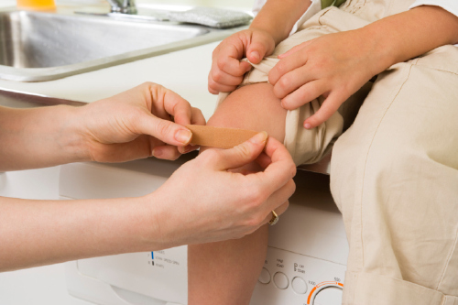](http://www.google.com/url?sa=i&rct=j&q=smiley+face+scrape+knee&source=images&cd=&cad=rja&docid=kmIHGEgnK033EM&tbnid=uLBQBCZO2RMW6M:&ved=0CAUQjRw&url=http://www.femalefirst.co.uk/parenting/news+on+parenting-255779.html&ei=et-bUcnaIKLI0QGtwoHoCQ&psig=AFQjCNEgxjicAA1_ElQAAkJSI-EjtY4hdg&ust=1369255597590171)[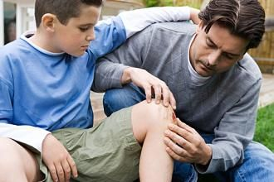](http://www.buzzle.com/articles/knee-pain/)

When I get hurt and tell an adult, it will help me feel better. They may even put a band aide on my boo-boo……..

And give me a big hug to help me feel better.

[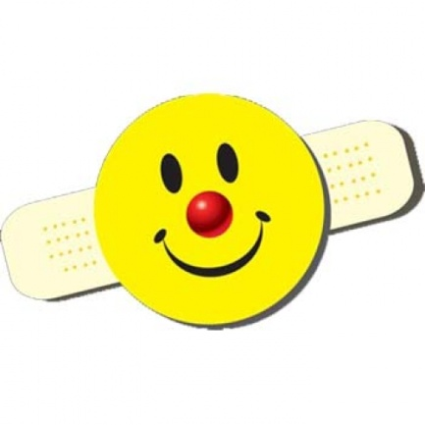](http://www.google.com/url?sa=i&rct=j&q=smiley+face+boo+boo&source=images&cd=&cad=rja&docid=0of3a-W1r7Ru7M&tbnid=Jd_RQQgQGh_nkM:&ved=0CAUQjRw&url=http://www.clownantics.com/clown-stickers/smiley-boo-boo-bandage-stickers-1472-95-p.html&ei=RtubUcO5Jcq-0AGl54HADg&bvm=bv.46751780,d.dmQ&psig=AFQjCNEJkhg0rwwBGXywBCOtVwT3AzQIKQ&ust=1369254916612403)

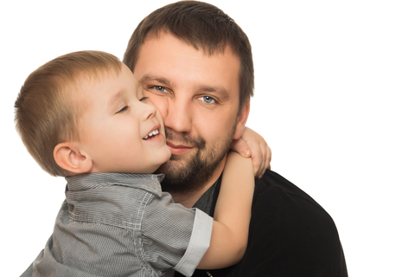

[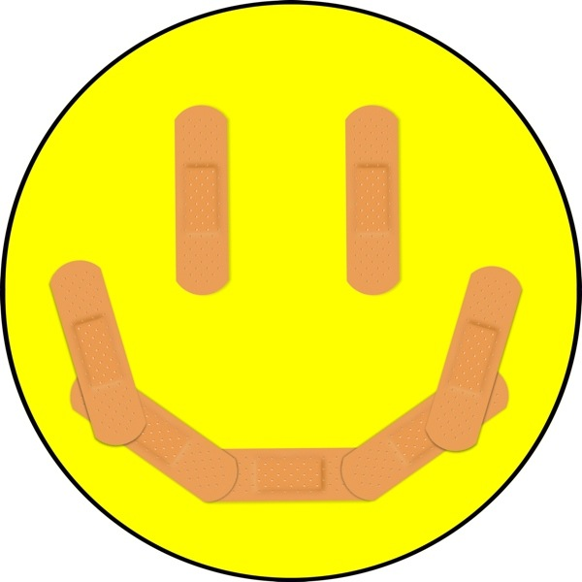](http://www.google.com/url?sa=i&rct=j&q=smiley+face+scrape+knee&source=images&cd=&cad=rja&docid=NxTRiMCMx9bgxM&tbnid=o6LvmcHua6DndM:&ved=0CAUQjRw&url=http://feminspire.com/4-items-for-quick-beauty-fixes-never-leave-home-without-em/&ei=G9-bUcHBIqO-0gG_oYCIDA&psig=AFQjCNEgxjicAA1_ElQAAkJSI-EjtY4hdg&ust=1369255597590171)

Then it won’t hurt so much anymore.