What is a Teacher’s Job?
At my school there are many teachers. There are probably more than 50 teachers!
Most kids think that a teacher’s only job is to teach.
That is a big mistake. There are SO many things teachers have to do before and after they do the teaching!
Here are some of the things.
Teachers get to school early to start their work – before the kids even get on their bus or come to school, maybe before they are even out of bed!
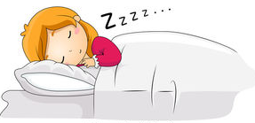
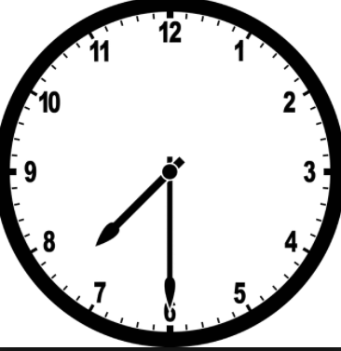
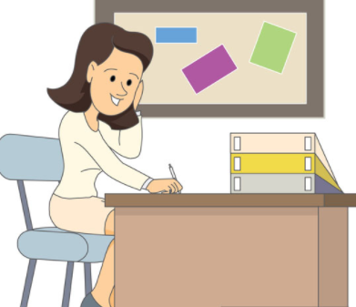
Teachers have to make their lesson plans and figure out what to teach the students every single day for the week.

They have to study just like kids because they have to know about reading, writing, science, social studies, math, and lots of language arts information.
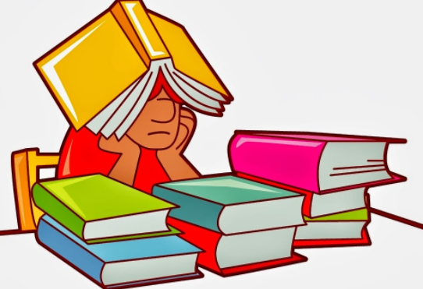

Teachers have to go to classes just like kids to learn what to teach at [your school name].
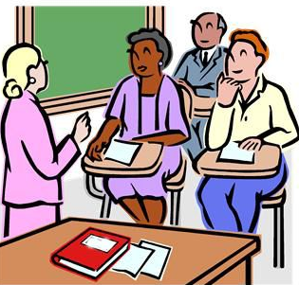
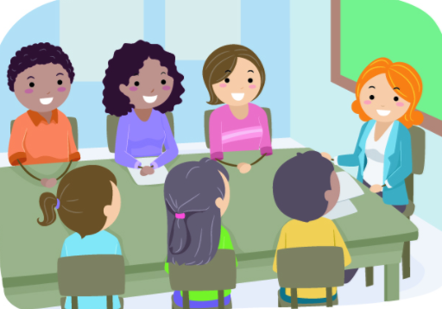
They have to go to many meetings with their principals, with families, and with other teachers.

They have to take attendance, get the lunch count, help with the busses, keep parent notes, put grades into the computer, check all the papers, organize and go on field trips, talk to parents on the phone and on email, and many more jobs. WHEW! That is a lot!
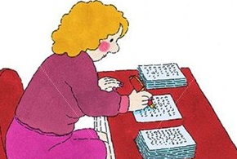
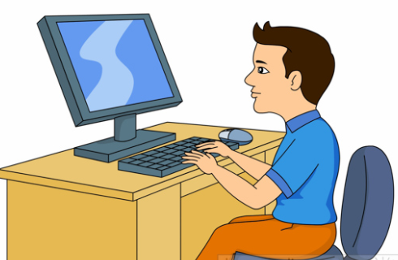
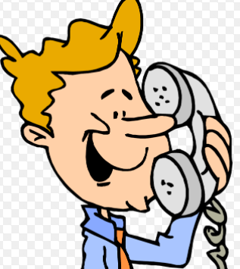
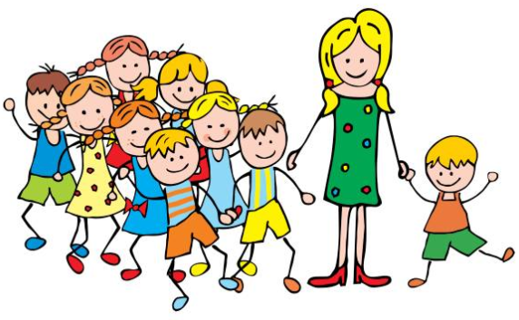
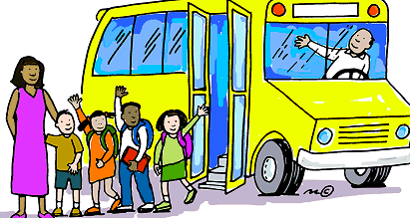
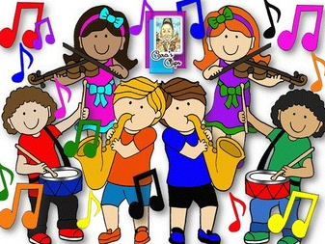
Gym teachers, music teachers, art teachers, and library teachers have a really big job. They have to make lessons and teach for EVERY child in the building!
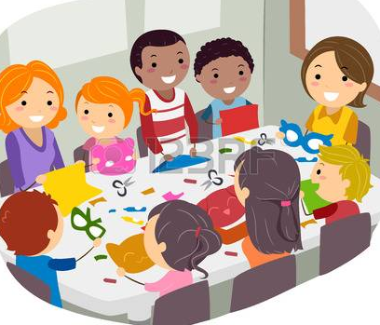
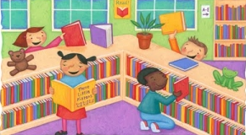
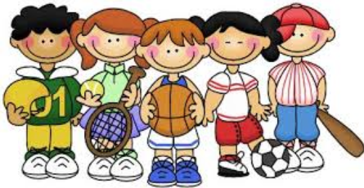
Teaching specials classes is really hard work because there are so many kids. Teachers work so hard to try and give kids turns and help them to enjoy and learn. They also have to keep everyone safe.
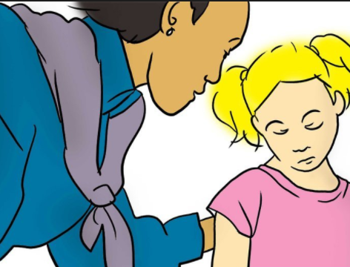
Teachers are always available to listen to kids explain their problems too. If a child is having a problem or is upset they can tell the teacher how they feel. That is their job too.

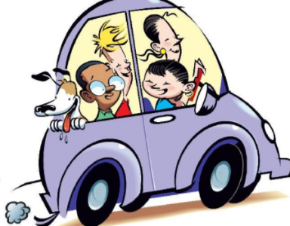
After a long day at school kids can go home and play. Teachers stay at school after the kids leave and continue to work. After that many teachers have to go home and take care of their own children. They might have to make dinner, take them to activities, and help with homework. So many teachers have 2 big jobs!
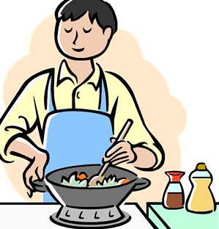
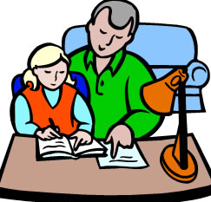
They must be very tired at the end of the day.
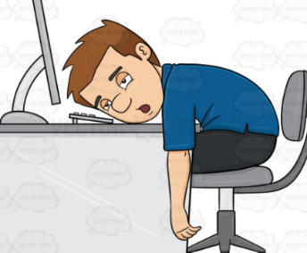

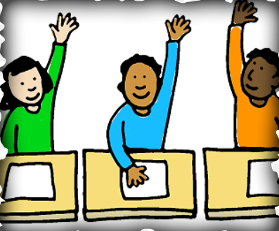
That is why it is so nice when kids can show respect to teachers by asking nicely for help, telling their problems in a good way, and following the rules the best they can.
Teachers love to teach kids. And kids try hard to make teaching fun for themselves and for their teachers too!
