

What Should I Do When I’m Really Upset?

Usually everything at school is just fine. Kids listen to teachers and do work, share, and play.
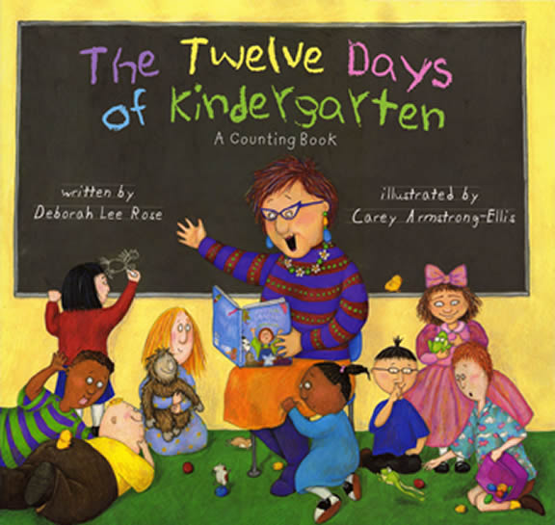

But, sometimes a kid can get really upset. I do!

Sometimes I just want to scream.

Sometimes I just want to fall down.
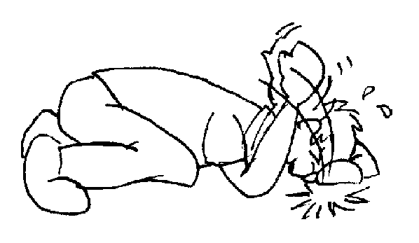

Sometimes I just can’t move.

When I feel like that I can do things to feel better!

I can squeeze my hands and pretend I’m squeezing an orange!

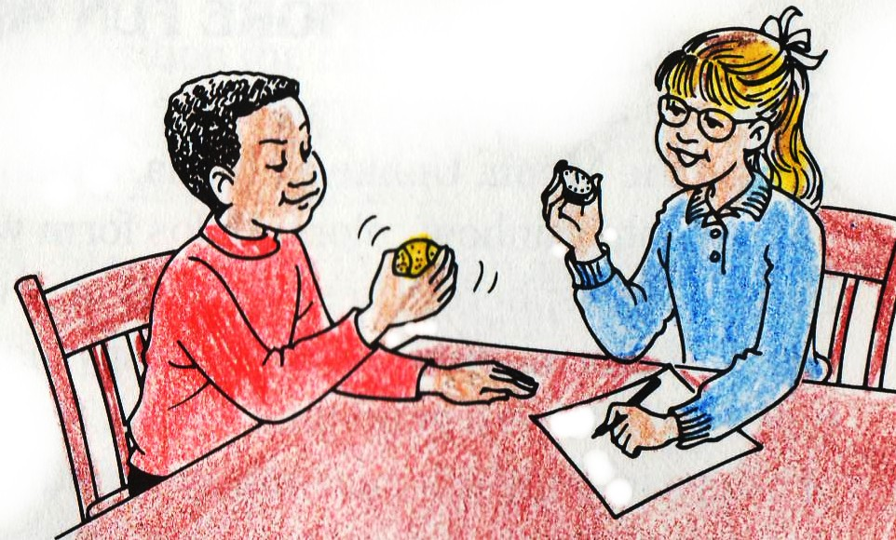


THEN I GET THE TEACHER TO HELP ME FEEL BETTER. SHE WILL KNOW WHAT TO DO.



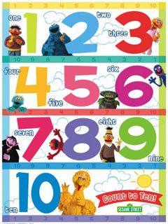
I can count to 10 slowly.

THEN I GET THE TEACHER TO HELP ME FEEL BETTER. SHE WILL KNOW WHAT TO DO.

I can get quiet and still and pretend I’m in a shell like a turtle.

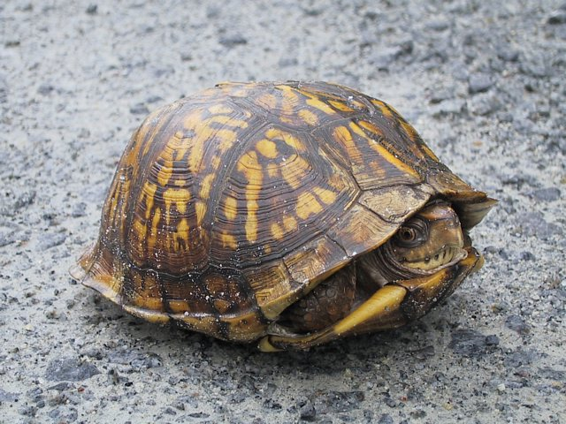

THEN I GET THE TEACHER TO HELP ME FEEL BETTER. SHE WILL KNOW WHAT TO DO.

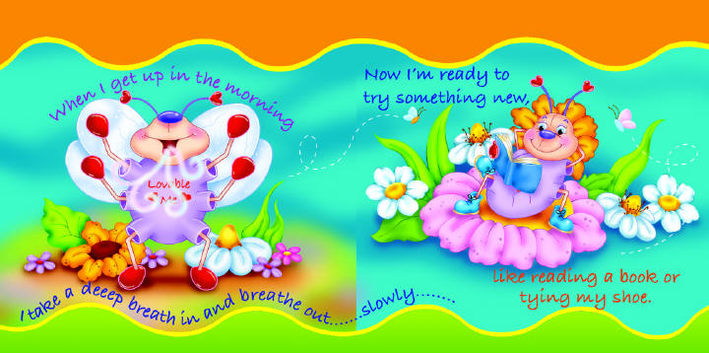
I can remember this rhyme and breathe in and out slowly.

THEN I GET THE TEACHER TO HELP ME FEEL BETTER. SHE WILL KNOW WHAT TO DO.

