

What Should I Do When I’m Really Upset?

My name is _________. I go to _________ School.
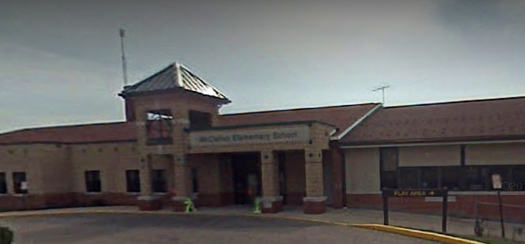

Insert school pix here

I am in kindergarten. My teachers are __________ and _________.
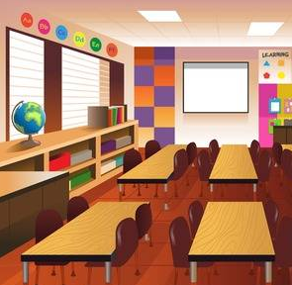
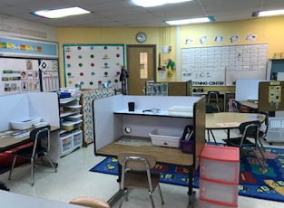
Insert Classroom Pix here

I like to work at my table. I like to play with my friends. I like my friend __________.
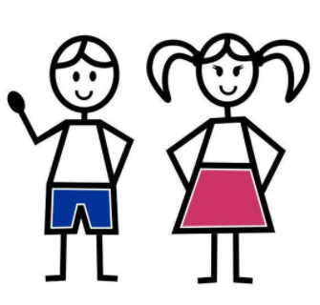


But, sometimes I can get really upset.
Sometimes I just want to scream.

Sometimes I just want to fall down.
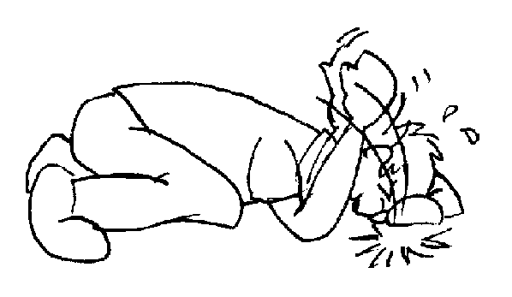

Sometimes I just can’t move.

When I feel like that I can do things to feel better!


_______,
I know what you can do when you are angry!!!

You can try to squeeze your hands and pretend to squeeze an orange!
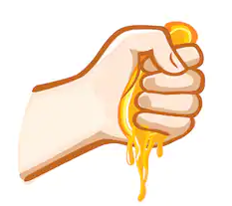


You like to spell things. You can stand up and start to spell!

You can spell ‘S-T-A-N-D’ and then stand up!

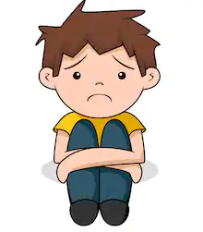
I can spell
S-T-A-N-D!
I will stand up!

Hey _______, you can spell:
H-E-L-P! And someone can help you!


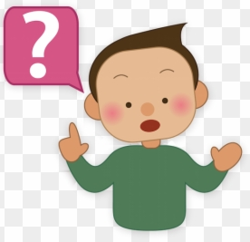
I’ll try to do that!
“I need
H-E-L-P!

Hey _______, when I get upset I bark too loud!


I’m going to try and be quiet to get help! I can use my paws. And you can use your words! No more barking and no more screaming!

So I will try to use my paws when I’m upset. You can try to use your words! You can say it or spell it!
I’ll use my paws to talk – it is quiet and nice! NO BARKING!


And I’ll try to use my words and NO SCREAMING!

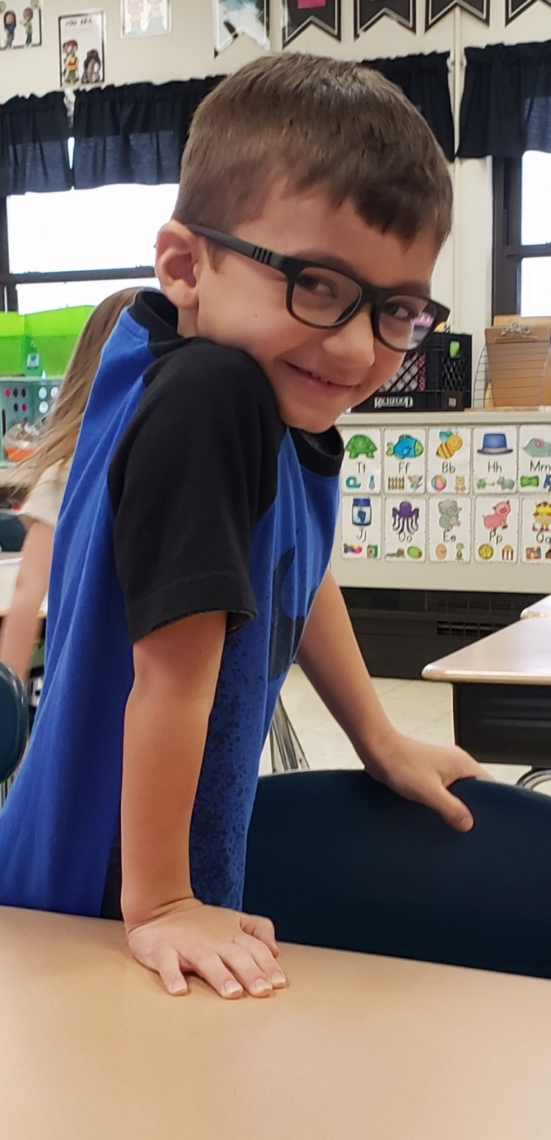
Insert Student Picture Here

Remember when you are upset:

- Pretend to squeeze an orange!
- Use your words
- You can spell too!
- H-E-L-P
- S-T-A-N-D
- Try NOT to scream!

