Sid the Science Kid and [Student Name]

My name is [student name].

I go to [SCHOOL NAME]
Insert SCHOOL PICTURE

I like to come to school!
I like [insert names of adults student is typically with and how he/she addresses the person]

I like [insert kids names]

Sometimes I can’t walk into another room.
Sometimes I have to stop. Sometimes I have to
____________ [ describe what she/he does at times].

When I ________ it makes me feel safe.

Sid the Science Kid says I can feel safe if I hold
___________ hand.
I can hold her hand and walk in.
Hey [student name], just hold hands and walk inside! You can do it!

Or I can hold her hand and jump in the room.

Or I can hold her hand and skip into the room.

Then I can feel SAFE! That will be fun!!

Sid the Science Kid said I can also try to step on my footprints to walk in! That is fun too! Then I will be safe!

Hey that’s fun [student name], step on the prints and walk right in!

Which one will I pick today?

Hold hands and walk in

Hold hands and jump

Hold hands and skip

Walk on my footsteps
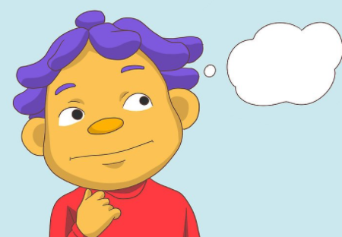
I wonder which one
[student name] will pick.. Go inside [student name], you are SAFE!

I’m Watching you [student name]! Just go in. You are SAFE!
PICK ONE:
- Hold hands and walk in
- Hold hands and jump in
- Hold hands and skip in
- Hold hands and walk on foot steps

