Using Glue

At school we do crafts and make things that use glue.
I like to make things at school.
I like to use glue.
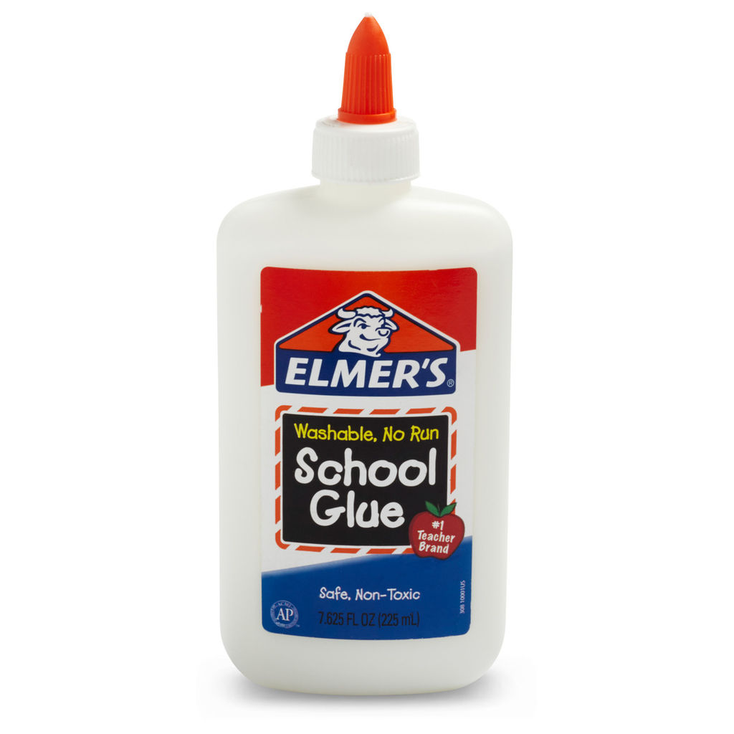

When we make things at school it is important to use the right amount of glue.
If I use too little glue things won’t stick.
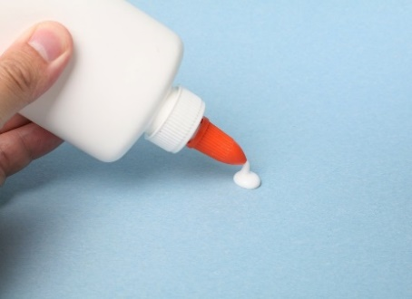

If I use too much glue everything gets covered in glue. It could make my paper too wet, it won’t be sticky and the glue will drip or it may rip the paper. It could even ruin my work.
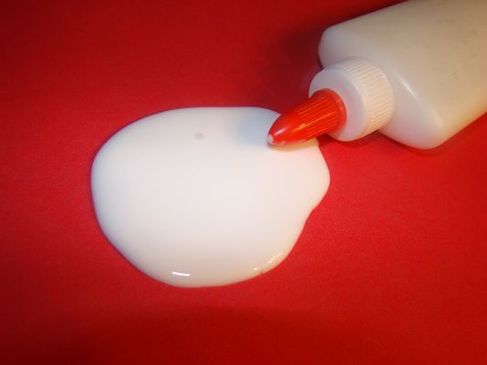
I will try to use just the right amount to make the glue stick
and it will look great
