Thomas needs to go!
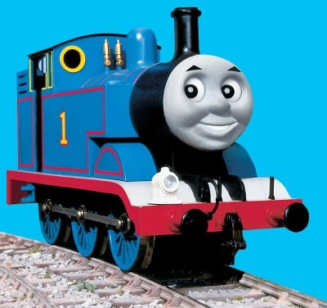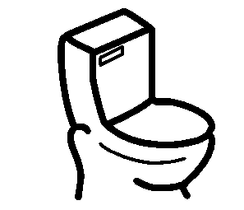

Sometimes Thomas needs to use the bathroom.
He doesn’t want to become too full.

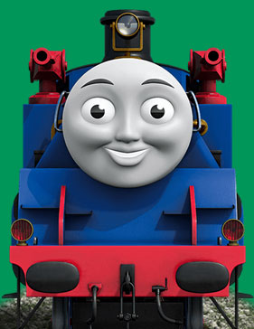
Thomas and his friends tell a teacher when they need to use the bathroom. Sometimes they have to go when they are playing. Thomas always asks to use the bathroom.
My teachers will help me if I have to go.. They will take me to the bathroom and help me.

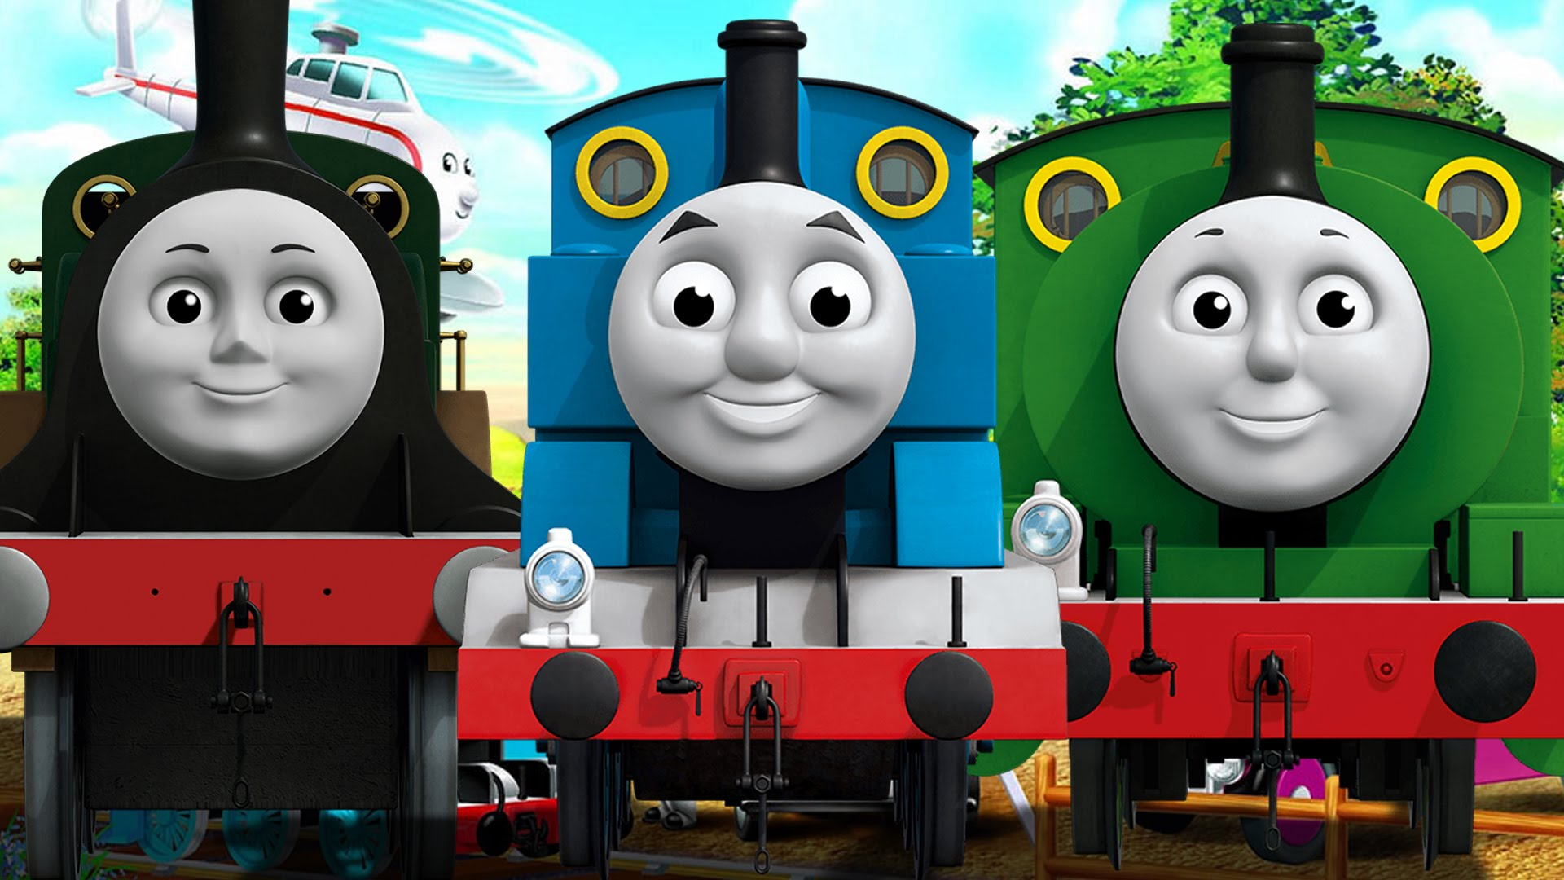

Thomas pulls down his pants to use the bathroom. Sometimes, Thomas needs to sit on the toilet longer to finish going. He can’t ride the railroad tracks if he has to go to the bathroom. 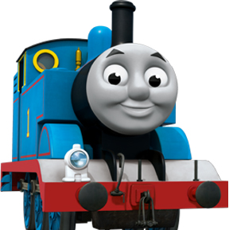 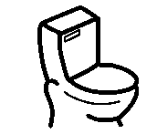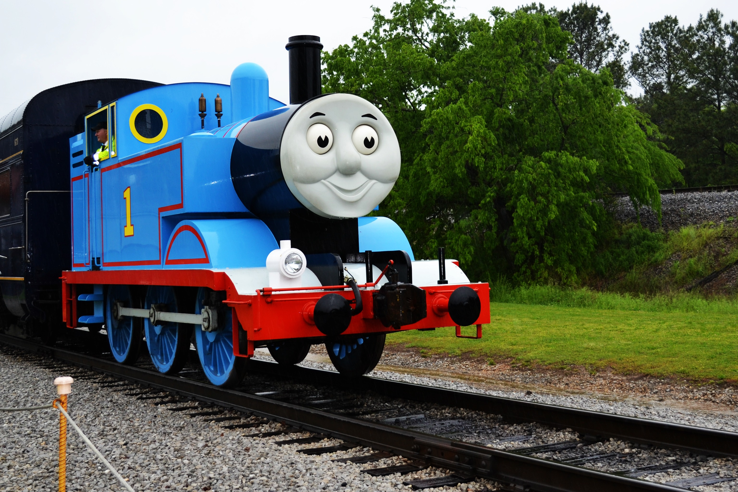

Thomas can’t play when he has to go to the bathroom. When he is playing he needs to stop for a couple minutes and go to the bathroom and use the toilet.
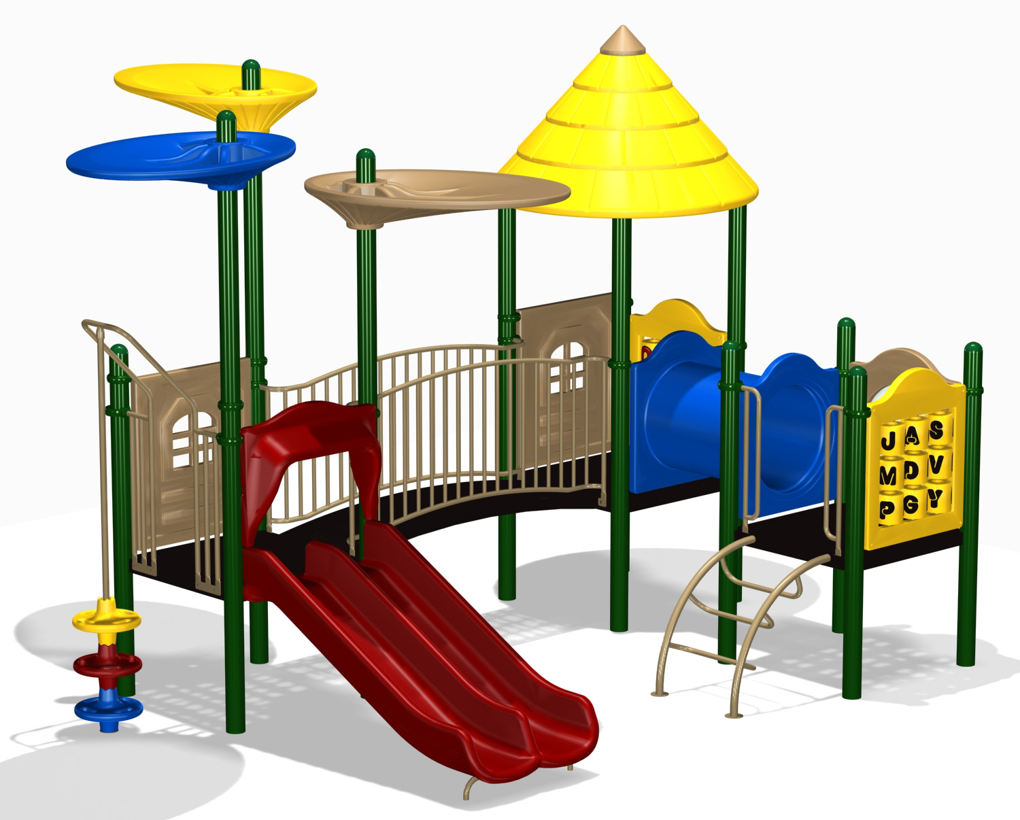

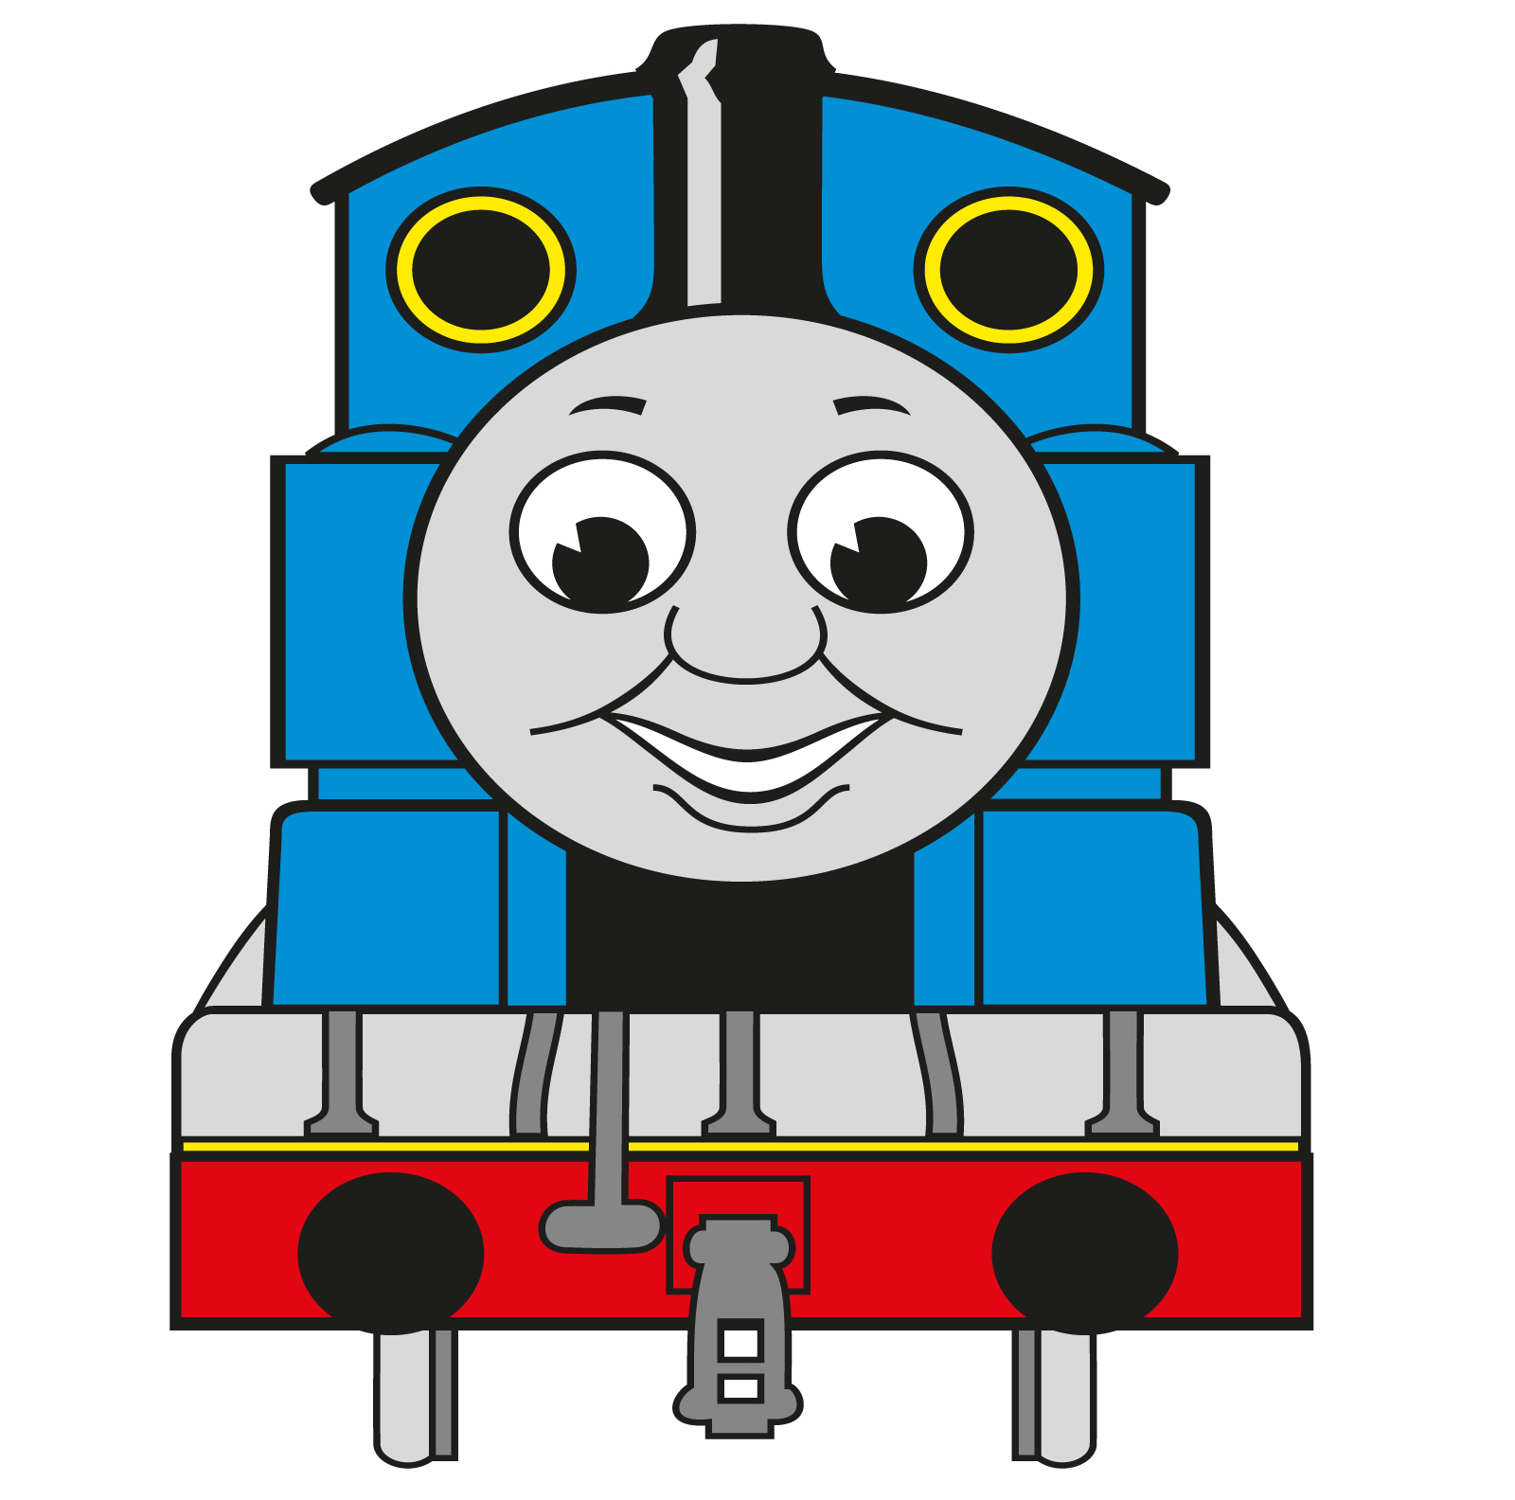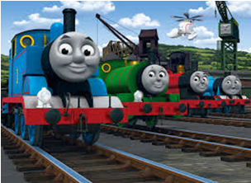

Thomas needs to flush after he finishes going in the toilet. Then, Thomas pulls up his pants.
My pants are on. I’m ready for action.
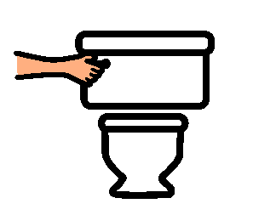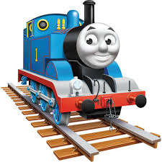

Thomas needs to wash his hands. Thomas’ hands are all clean. He’s ready to go for a ride !

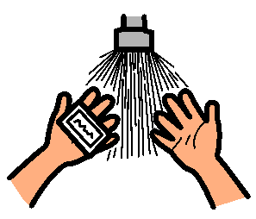
See. I washed my hands.

Thomas will tell the teacher when he is finished. His teacher is happy when he follows directions! He is a good guy.

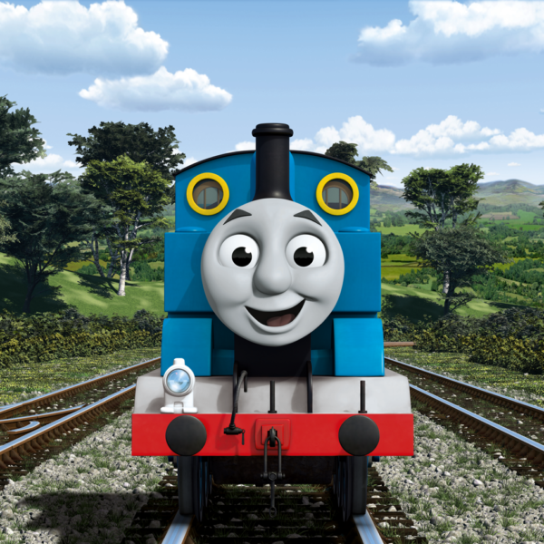

The End

