Taking the PSSAs
In the state of Pennsylvania, kids who are in 3rd grade and up are now old enough to take the PSSAs.
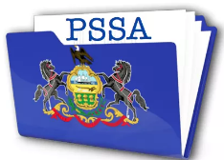

These are ‘tests’ that can show what school has taught so far. It also helps to tell teachers what and how they should teach in the future.
Insert student Special Interest Character here with surprised look
Taking the PSSA actually helps teachers?! Cool!

At [insert school name here] they let some kids take the test with a teacher they know AND in a quiet area so you can think better!
And even better a kid can help figure out when he or she wants to take breaks AND what the breaks can be (within reason )
Wait, What? You can take breaks and come up with them?!
Insert student Special Interest Character here.

But wait, here is a question, what if a kid loves to draw on their work? And..is really good at it?
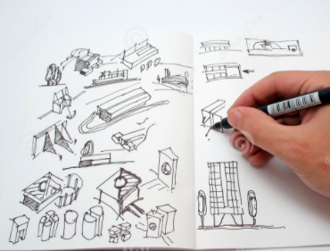
The law says all the tests are to be sent to the State of PA and they need tests to be free of anything but the answers. So…one solution is to give the student their own Drawing Book. The student can then decide if he or she wants to keep their book with the drawings or send in for the state to see.
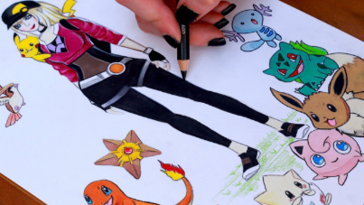
Finally, kids should remember that if they get frustrated with anything in the test, simple, just ask for a break!
OK break here needed!
Insert a Special Interest Character here

Taking the PSSA’s is different, but actually might be kind of fun!
Insert Special Interest Character with thumbs up here

