Superflex and Spider Man Can Help Me!
Characters from Stephane Madrigal and Michelle Garcia Winner

My name is _________ and I go to _________ Primary School.

Insert School Picture here

I’m a pretty good student and My teachers __________ and ___________ really like me!
But sometimes villians try to trick my brain!
One of the villians is called Empathy Eraser. Empathy means being nice to my friends. But Empahty Eraser tries to take away my niceness or my empathy. He tries to ERASE my empathy! How mean is that?!
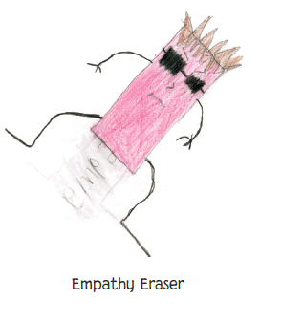
I have the power to make _________ do things that will hurt his friend’s feelings!

I know _________is nice to his friends but I want to erase his niceness
I won’t let you do that to _________ Empathy Eraser! I will save you Christian

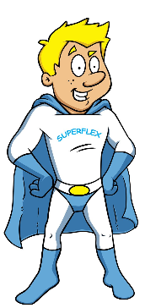

Batman, want to help me erase the Empathy Eraser and save ________?
Sure, maybe _________can give us some ideas how to fool ERASER

Hey _________, help us fight Empathy. You can give us ideas and [teacher name] can take your picture doing the tricks. Then you can be in this story too! Here’s some ideas:
If you get mad don’t let Empathy Eraser make you be mean to your friend. Just:
Put your hands in your pocket and tell an adult

If you are angry, don’t say something mean. Tell an adult to write down your feelings!

What are your ideas to defeat Empathy Eraser?

