

I’m so angry. What should I do?


Clifford Gets Angry

Sometimes Clifford gets angry.
Sometimes I get so angry and frustrated I just want to kick and push something!
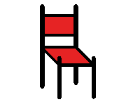

Sometimes Clifford feels like saying bad words or he feels like yelling.

I just want to yell out loud. Sometimes I forget and say bad words




Emily says, “Don’t kick or push Clifford, someone might get hurt!”

Emily says, “Don’t yell Clifford! That hurts your friends’ ears. Don’t say bad words Clifford. That makes your friends and teachers feel sad.

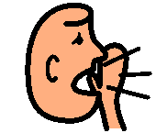

Emily says, “Guess what Clifford? There are other things to do if you’re angry.”

Clifford wants to know what to do if he’s angry. He wants to know what to do if he’s frustrated. Clifford does not want to hurt anyone. He does not want to kick or yell.

What can I do when I’m angry or frustrated Emily?

I can tell you some good things to do when you are angry Clifford!

Here are some things Clifford can do:

- Breathe 3 times

- Count to five

- Say to adult, “Help me, I’m upset”
“I might need to take a break.”

I’m going to try that! I’m going to try to breathe 3 times then count to 5. Then I’m going to tell an adult I need help. I might need a break. I’m going to try and say it in an inside voice!!!



Sometimes I feel angry, too. Sometimes I feel frustrated.
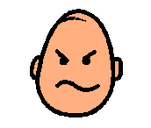Angry??? Frustrated???

When I feel Angry or Frustrated I will try to remember:

No kicking No yelling or bad words

I can do other things when I am angry or frustrated. I can:

- Breathe 3 times 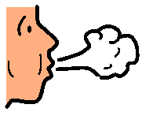

- Count to 5 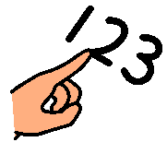

- Say to adult, “Help me, I’m upset”
“I might need to take a break.”

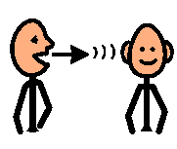

Thanks for helping Emily!!

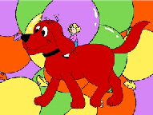
You remembered to use nice words when you were angry. You remembered to breath and count!!

Every one will be happy when I remember what to do when I’m angry or frustrated, especially Clifford and Emily!!

