Sometimes Teachers HAVE to Correct or Help Other Students – THAT IS OK!

My name is _____ and I go to __________________ School.

I do good work in school. I like my teachers.
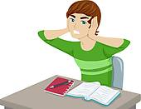
Sometimes I think it gets too loud.

Sometimes teachers correct other students.
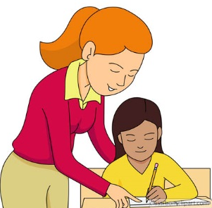
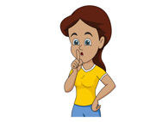

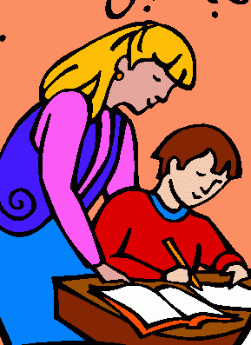
Sometimes teachers help other students.

That is the job of the teacher. A teacher is supposed to help and correct other students. That is the school Rule for teachers
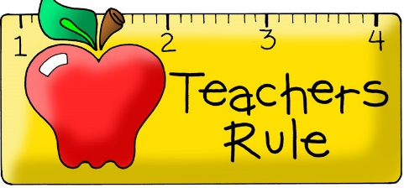

If it is too loud for me or if this bothers me I just have to tell __________

[Could insert picture of student with selected adult]

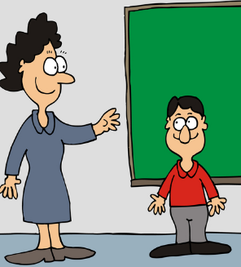
I can say:
It is too loud, may I walk out
It is loud may I get a drink?
It is loud may I walk out with you?

It is OK if teachers talk to students. It is OK if teachers correct student.
It is OK if a teacher helps a student.

I can ask to leave. I can ask quietly. No screaming or yelling. Just ask to leave. I can give a note too! I just hand the note to an adult.
May I please leave – it is too loud.

[Could insert picture of student handing note]
_____ if it is too loud, give a note or quietly ask to leave. Remember:
NO YELLING

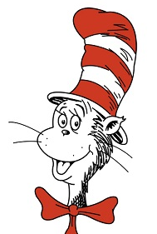
[insert motivating character – this is a sample]

