

Sometimes People Fart

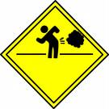

Everybody farts.

People sometimes laugh when I do a loud fart.

That makes me happy.

But there are other ways to make my friends laugh. I can tell a funny joke or make a funny face .

I really must not fart when there are people around. 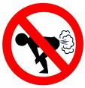

I must only fart when I am in the
bathroom or outside , or
when I am alone .

I if I need to fart, I need to ask to go to the bathroom, or outside.

Nobody likes to smell my farts. 
I might like the smell, but other people do not.

My friends are happy when I don’t fart .

My teacher is very proud when I don’t fart.

