

I’m so angry. What should I do?

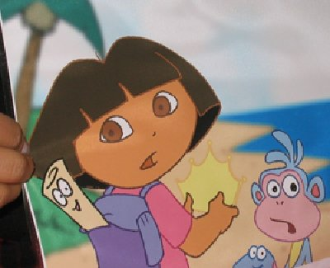
Dora the Explorer Gets Angry
Sometimes Dora the Explorer gets angry.

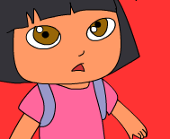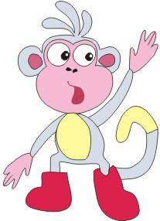
Boots, I’m so angry. I’m going to hit you.

Sometimes Dora feels like hitting someone.

Don’t hit Boots, Dora! That hurts! There are other things to do if you’re angry.

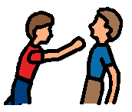 No Hitting!!!

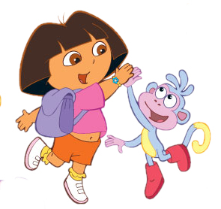

Dora wants to know what to do if she’s angry. She wants to know what to do if she’s frustrated. Dora does not want to hurt anyone.
What can I do when I’m angry or frustrated???

Here are some things Dora can do:

- Power Walk 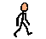
- Squeeze clay 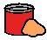
- Jump on the trampoline 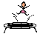
- Sit in the bean bag chair 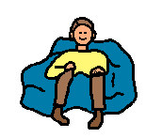

Sometimes I feel angry, too. Sometimes I feel frustrated.
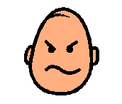Angry??? 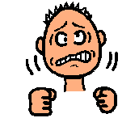Frustrated???
When I feel Angry or Frustrated I will try to remember:
No Hitting!!!

I can do other things when I feel angry:
- Power Walk
- Squeeze clay
- Jump on the trampoline
- Sit in the bean bag chair

Everyone will be happy when I remember what to do when I am angry or frustrated.

